Developing an Exclusions Policy – Guidance for Schools
Published date: November 2018
Updated: January 2020

Contents:
Model Policy (tailored to the school/academy)
Appendix A: Exclusions Flowchart
Appendix B: Alternatives to Exclusion (Primary and Secondary)
Appendix C: Headteacher’s/Principal’s Exclusions Checklist
Appendix D: High Risk Group Terms of Reference and accessing support
Appendix E: Exclusions Guidelines linked to letters
Appendix F: Model letter 1 – Fixed Term Exclusion (up to 5 days/lunchtime exclusion)
Appendix G: Model Letter 2 – Fixed term Exclusion (6-15 days in one term)
Appendix H: Model Letter 3 – Fixed term exclusion (15 days or more in one term)
Appendix I: Appendix G – Model Letter 4 – Permanent Exclusion
Appendix J: Model Letter 5 - From the Governing Body of a school notifying a parent of its decision not to reinstate a pupil

Rationale:
All pupils in our school/academy benefit when behaviour is good. High standards of behaviour are important to help children feel safe and learn well. Parents and carers play an important part in this.
The government advises schools to focus on promoting positive behaviour, helping to build self-discipline and encouraging respect for others. Schools also need sanctions to deter pupils from misbehaving. This policy should be read in conjunction with our school/academy Behaviour Policy, SEND/Inclusion Policy and Single Equalities Policy.
The decision to exclude a pupil, either permanently or for a fixed period of time, will
therefore only be taken as a last resort and:
● In response to serious or persistent breaches of the school’s/academy’s Behaviour Policy
● If allowing the pupil to remain in the school/academy would seriously harm the education or welfare of the pupil or others in the school/academy.
The Headteacher/Principal is the only member of staff in a school who can decide to exclude a pupil from the premises.
This policy has been written following the 2017 guidelines outlined in the Department for
Education ‘Exclusions from maintained schools, Academies and pupil referral units in
England: A guide for those with legal responsibilities in relation to exclusion’ and relates to
the following ​ legislation:
● The Education Act 2002, as amended by the Education Act 2011;
● The School Discipline (Pupil Exclusion and Reviews) (England) Regulations 2012;
● The Education and Inspections Act 2006; and
● The Education (Provision of Full Time Education for Excluded Pupils) (England)
Regulations 2007
https://www.gov.uk/government/publications/school-exclusion Please note: specific guidance for Head Teachers and Parents/Carers at the back of this document (Annex B and Annex C).
Decision Making:
Before reaching a decision to exclude either permanently or for a fixed period, the Headteacher/Principal will:
- contact the LA Education Inclusion Officer (EIO) for primary/secondary and seek advice and support and consider whether this case meets the criteria to take to High Risk Group (Andy Holliday – secondary andy.holliday@pathwayslearningcentre.org or Nicola Joyce – primary Nicola.joyce@pathwayslearningcentre.org ) Appendix D
- contact the Chair of your local SEND Cluster to consider if a request for additional funding for this pupil may be appropriate, using a costed provision map
- consider all relevant facts and such evidence as may be available to support the allegations made, taking into account the School’s Behaviour and Single Equalities Policies;
- allow the pupil to give his or her version of events;
- check whether the incident may have been provoked for example, by racial or sexual harassment;
- take account of any contributing factors that are identified after an incident for example, if a pupil has been subject to bullying, suffered a bereavement or has mental health issues;
- consider the impact of exclusion on certain vulnerable groups, including pupils with additional learning needs and ‘Children in Care’;
- consult others (whilst not using the pupil’s name), including the CEO or Local Authority Officer (if a permanent exclusion), being careful not to involve anyone who may have a role in any statutory review of his or her decision, for example, members of the Governing Body’s Discipline Committee;
- keep a written record of the actions taken, including any interview with the pupil. Witness statements must be dated and should be signed, wherever possible;
- ensure that the decision to exclude is made in line with the s of administrative law i.e. that it is:
Lawful (with respect to the legislation relating directly to exclusions and the School’s wider legal duties, including the European Convention of Human Rights);
Rational;
Reasonable;
Fair; and
Proportionate
- establish the facts in relation to the exclusion, applying the civil standard of proof i.e. ‘on the balance of probabilities’ it is more likely than not that a fact is true, rather than the criminal standard of ‘beyond reasonable doubt’
South Gloucestershire Council and this school do not authorise the use of unlawful ‘informal’ or ‘unofficial’ exclusions where pupils are sent home, even with the agreement of their parents/carers, for a ‘cooling off’ period. Any exclusion of a pupil must be formally recorded. The Headteacher/Principal is responsible for the safeguarding of all pupils on roll during the school day. The only times they are not responsible are if the child is ill and has been kept at home or if they are formally excluded and the responsibility goes to the parents/carers. Elective Home Education (EHE) should never be referred to or encouraged by the Headteacher or member of staff at the school as an alternative to exclusion.
Alternatives to Exclusions
_______ school/academy is committed to using exclusion only as a last resort. Alternatives will always be considered and may include:
- the use of the Early Help process, working with external agencies and parents/carers to provide support through a Single Assessment for Early Help (SAFeH) and person centred planning approach;
- restorative justice processes;
- the use of the ‘alternatives to exclusion checklist’ and support from the Inclusion Support Worker Education Inclusion Officer (via Pathways Learning Centre);
- internal isolation (where appropriate, in line with school’s Behaviour Policy);
- a managed move, in line with the locally­agreed protocol (See Fair Access Protocol for more information) http://www.southglos.gov.uk//documents/Fair-Access-Protocol-June-2018.pdf
Fixed term exclusions
The Headteacher/Principal may exclude a pupil for up to 45 days in any one academic year. Generally, fixed­term exclusions will be for one to three days. No exclusion will be given for an unspecified period of time.
A fixed­term exclusion does not have to be for a continuous period. In exceptional circumstances, where further evidence has come to light, a fixed­term exclusion may be extended or converted to a permanent exclusion.
Procedures for review and appeal of fixed term exclusions
A fixed­term exclusion, which does not bring the pupil’s total number of days of exclusion to more than five in a term (two termlets), will not usually be reviewed by the Governing Body Disciplinary Committee unless a written request is submitted by a parent/carer, within 50 school days of receiving the notice of the exclusion, to review the decision; however, it cannot direct reinstatement.
If a pupil is excluded for more than five days (but not more than 15) in a single term (two termlets), the Governing Body Disciplinary Committee will consider the reinstatement of the pupil, if requested to do so by the parent/carer in writing, within 50 school days of receiving the notice of the exclusion.
If a pupil is excluded for 15 days or more in one term (two termlets), the Governing Body Disciplinary Committee will meet to consider the reinstatement of a pupil within 15 school days of receiving notice of the exclusion.
If, as a result of a fixed­term exclusion, the pupil will miss a public examination or National Curriculum test, the Governing Body Discipline Committee will meet to consider the exclusion before the date of the examination or test. If it is not possible for the Governing Body Disciplinary Committee to meet, the Chair of the Governing Body/Academy Board may consider the exclusion independently and decide whether or not to reinstate the pupil.
A summary of the exclusion process and the Governing Body’s duties to review exclusion decisions is shown in the flowchart, Appendix A.
Where a pupil has received multiple exclusions or is approaching the legal limit of 45 days the Headteacher/Principal will consider whether exclusion is providing an effective sanction.
When excluding a pupil who is a ‘Child in Care’, the Headteacher/Principal will ensure that the appropriate ‘home’ Local Authority Officer is informed
Permanent exclusions
Permanent exclusions will normally be used only as a last resort when a range of other strategies have been exhausted.
In exceptional circumstances, where a serious breach of the School’s/Academy’s Behaviour Policy has occurred, the Headteacher/Principal might consider it appropriate, having consulted with the CEO/DCEO or LA Officer, to permanently exclude a pupil for a first or one­off offence. Such circumstances might include:
- Where there has been serious actual or threatened violence against another pupil or member of staff;
- Sexual misconduct;
- Supplying an illegal drug, as defined within the School’s/Academy’s Drugs and Substance Abuse Policy;
- Carrying an offensive weapon;
- Any severe form of bullying including racist or homophobic bullying; and/or
- Any action resulting in a serious health and safety issue.
In cases where a criminal offence has taken place, the police and, where appropriate, the Youth Offending Team, Social Services or any other outside agency involved with the pupil may be informed.
A Headteacher/Principal should, as far as possible, avoid excluding permanently any pupil with a statement of SEN or a ‘Child in Care’. Before making the decision to permanently exclude a pupil who is a ‘Child in Care’ the Headteacher/Principal will discuss with the appropriate ‘home’ Local Authority Officer the availability of a suitable, alternative appropriate school or provision elsewhere.
If the Headteacher/Principal decides to exclude a pupil permanently they will inform the Local Authority Exclusions Officer, Guy Halley, at the earliest possible opportunity. If the pupil lives outside the Local Authority area in which the School/Academy is located the Headteacher/Principal will also advise the pupil’s ‘home authority’ of the exclusion without delay.
Following permanent exclusion the Governing Body is required to review the Headteacher’s/Principal’s decision. This review is to be carried out within 15 school days for the notice of exclusion.
The school must provide the governors (a panel of a minimum of three governors is required for this) with a full account of the reason(s) leading up to the permanent exclusion. The parent/carer and a Local Authority representative should also receive all this information. The governor review meeting is a formal meeting and must be taken seriously.
From day six of a permanent exclusion the Local Authority becomes responsible for the pupil’s education. This will be organised through a Pupil Referral Unit (PRU). A placement in a Pupil Referral Unit is not supposed to be long term. An assessment will be carried out and the Local Authority will support the pupil to address the issues which lead to the permanent exclusion.
Process for notification of a fixed term exclusion of more than five consecutive days
A Headteacher/Principal must, without delay, notify the Governing Body and the Local Authority of:
- a permanent exclusion (including where a fixed period exclusion is made permanent)
- fixed-term exclusions which would result in the pupil being excluded for more than five school days (or more than ten lunchtimes) in a term
- fixed-term exclusions which would result in the pupil missing a public examination or national curriculum test
​Procedures for review and appeal of permanent exclusions
The Governing Body Discipline Committee will consider the reinstatement of an excluded pupil within 15 school days of receiving the notice of the exclusion, invite the following parties to attend and circulate to them any written evidence and information received, within five school days in advance of the meeting:
- Parents/Carers;
- the Headteacher/Principal;
- CEO/DCEO; and
- a representative of the Local Authority (although this is not a requirement for
academies, it is advisable)

During the meeting, the Governing Body Discipline Committee will consider the interests and circumstances of the excluded pupil, including the circumstances in which the pupil was excluded, and have regard to the interests of other pupils and people working at the school/academy.
The Governing Body Disciplinary Committee, when establishing the facts in relation to the exclusion, must apply the civil standard of proof i.e. ‘on the balance of probabilities’ it is more likely than not that a fact is true, rather than the criminal standard of ‘beyond reasonable doubt’. In light of their consideration, the Governing Body Disciplinary Committee can either:
● uphold the exclusion; or
● direct reinstatement of the pupil immediately or on a particular date.
The Governing Body Disciplinary Committee are legally required to notify the parents/carers, the Headteacher/Principal and the Local Authority of their decision, and the reasons for their decision, in writing and without delay.
The Governing Body Disciplinary Committee will notify the parents/carers of the date
by which an application for an Independent Review Panel must be made, which is 15
days from the date of the notice in writing.
If parents/carers apply for an Independent Review Panel within the legal time frame,
the Governing Body/Academy Trust will arrange for a hearing to take place, within 15 days of the parental notification, to review the decision of the Governing Body not to reinstate a
permanently excluded pupil.

Appendix A – Exclusions Flowchart
NB: Term refers to 2 small ‘termlets’

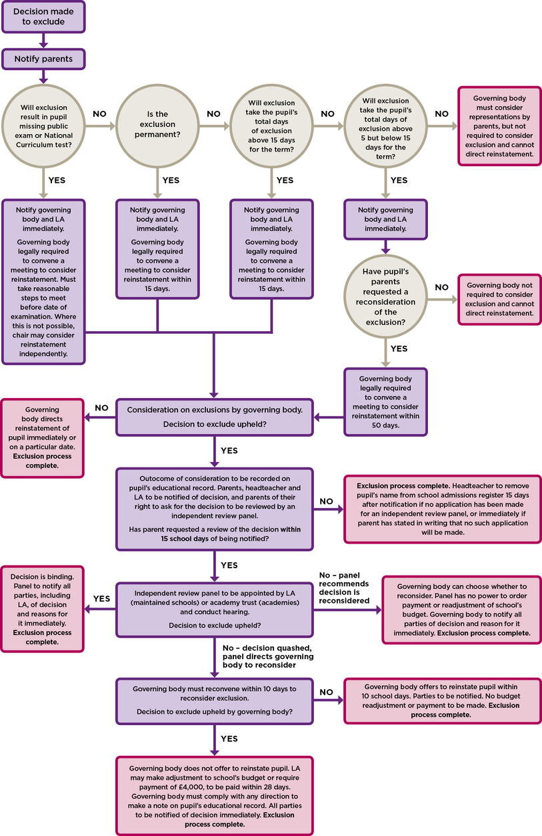

Appendix B – Alternatives to Exclusion Checklist Primary

SEN STATUS
EHCP
SEN K

SAFEGUARDING CONCERNS
ART referral
SERAF
My concern

PARENTAL ENGAGEMENT
Regular contact/engagement with behaviour plan

RESPONSE TO ESCALATING BEHAVIOUR
Different day intervention
Fixed period exclusions
Internal exclusion/seclusion

BEHAVIOUR DATA INTERVENTION
Patterns of negative incidents from Teachers have been addressed
The data is analysed regularly

SPECIALIST INTERVENTION
Referral to EPS
YOT
FYPS
CAMHS
ISS
School nurse
Social Care
GP/Paed/Medical

LEARNING INTERVENTIONS

Personalised learning/timetable change
SMART targets/daily positive report card
Literacy assessment
Tutor change/house change/class swap
Classroom observations
(frequency/ABC charts
Student passport/plan to share strategies of support
Additional support in class (not related to SEN)
Academic mentoring
Wave 2 SEN assessment
Additional literacy/maths intervention

ALTERNATIVE PROVISION
In school inclusion facility
Off-site provision (CLIC, Engage)
Work experience
Specialist mentoring (Breakthrough, Impact)
Early intervention strategies
(school swap/intervention moves)
College course
Work to Learn programme

ASSESSMENT AND PLANNING
SAF eh
ISS/PSP/BSP with regular reviews
Planning reviewed internally through 360* or similar
Change Tracker
Academic assessment review to check progress and access to learning
EP assessment
PASS/attitudinal assessment
Speech and language assessment
Medical needs assessment

RELATIONSHIP BUILDING INTERVENTIONS

Restorative mediation with key staff
Micro-management daily check in/debrief
Key adult support/mentoring
Peer mentor schemes
Student support/guild support services
Circle of adults with teaching staff
Counselling provision
Circle of friends/social skills

STUDENT FOCUSED INTERVENTIONS

Managing anger/emotions/conflict resolution
Social Skills/peer relationships
Mental Health
Classroom behaviour skills
Time out card
Head of Year/House/TA/Class Teacher support
Please also refer to additional guidance for schools on dealing with behaviour that challenges document
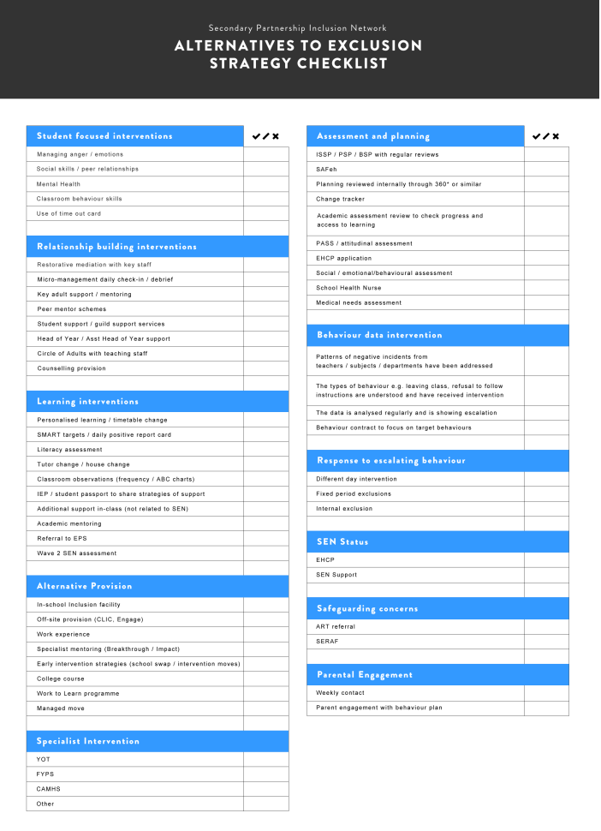

Appendix C – Headteacher’s/Principal’s Exclusion Checklist
 | Yes | No
On the balance of probabilities, did the pupil do it?

Does the incident represent a serious breach of the school behaviour policy / the final straw incident in a series of persistent breaches of the behaviour policy?

Does the pupil’s presence seriously harm the education/welfare of the pupil or others in the school community?

Is exclusion the appropriate response?
Factors to Consider
• Decision to exclude not taken in the heat of the moment
• A thorough investigation has been carried out
• Evidence has been considered in the light of policies and discrimination
• The pupil’s views have been encouraged, heard and recorded
• Mitigating circumstances and provocation (bullying etc.) have been considered
• Appropriate wider consultation has been considered

Has there been involvement from specialist teachers (SEND) or Behaviour/Inclusion Service or an Educational Psychologist?

Has a pastoral support programme been tried?

Has this case been bought to SEND cluster board or High Risk Group?
Is there an Early Help strategy/SAFeH in place?
Have alternatives to exclusion been considered? See Appendix B – Alternatives to Exclusion Checklist (e.g. restorative justice, mediation, internal exclusion, school to school managed move)?

Special Considerations
Does this pupil have an Education Health Care Plan [EHCP] (statement of special educational needs)?
If so:
- Have you contacted the special needs officer?
- Has an emergency annual review been called?

Is this pupil currently a child in the care of the Local Authority?
If so:
- Have you contacted the Head of the Virtual School and Social Worker?

Is this pupil subject to Child Protection procedures or a Child In Need?
If so:
- Have you spoken to the Social Worker?

Have issues of SEN, disability, race and care been fully considered?
See separate check list for considerations around the exclusion of children with SEN/disability

Has the appropriate length of exclusion been considered?

High Risk Group (HRG)
Terms of Reference
Rationale:
Escalating challenging behaviour resulting in the risk of permanent exclusion is often the result of complex experiences, catalysts and needs. Addressing these under-lying needs requires a coordinated inter-agency approach.
The High Risk Group is a joint Local Authority/ School Peer Review Panel which aims to reduce the need for permanent exclusion and improve outcomes for vulnerable children through inter-agency working.

Principles:
- Schools work to find solutions which are in the best interest of the child or young person.
- Schools are committed to engaging in a ‘collegiate/partnership approach’ in order to reduce exclusions.
- Schools are committed to assessing and planning for those at the highest risk of PEX/multiple fixed term exclusions.
- Schools are committed to identifying and supporting students that have additional/Special Educational Needs and or Disabilities.
- The meetings are confidential and sensitive information is shared with the members and Headteachers/School representatives only. Parents/carers will have given consent for their child’s case to be brought to HRG. All information and paperwork will be shared securely.

Purpose:
To prevent permanent exclusion by:
- Ensuring appropriate assessments, planning and interventions are in place for students at the highest risk of PEX or multiple fixed term exclusions.
- Offering independent view of current strategies.
- Sharing information from all appropriate agencies and facilitating inter-agency working.
- Providing advice and guidance to schools.
- Brokering support from agencies: Social Care; Youth Offending Team, FYPS, PLC, 0-25 Team, Integra, external providers etc.
- Brokering managed moves using Fair Access Protocols.
- Providing direct, short-term funding to allow schools to implement an appropriate, costed provision plan.
Quorate:
- The group will be quorate if it is attended by the Chair and at least 4 members (which must include the Education Inclusion Officer)
Membership:
- The High Risk Group will be chaired by a designated Headteacher for Primary and Secondary (agreed annually).
- Representative Headteachers (from Primary/Secondary) will attend regularly as members (on a rota basis).
- The following Agencies/ Providers/ LA Officers will be group members:
  - Representative from Integra Inclusion Team
  - Education Welfare Support
  - Youth Offending Team/ Police
  - FYPS
  - CAMHS
  - Education Psychology Service
  - 0-25 Team
  - Social Care/ Early Help Team
  - Pathways Learning Centre (HT & Primary/ Secondary Education Inclusion Officers)
  - Public Health
  - Barnardo’s
- Additional members may be co-opted to attend regularly or asked to attend specific meetings where appropriate.

Requests for HRG Involvement:
Before bringing a case to HRG schools will need to have:
- Demonstrated an appropriate level of school-based support via a ‘Plan, do, review’ approach, followed the guidance within the South Glos Way Graduated Response Toolkit.
- Attempted to assess and identify the child or young person’s needs (incl. SEND, SEMH and environmental factors) via professional assessments and/ or the SAFEH process.
- Made a referral to access funding via SEND cluster and carried out an impact review of this support. (See Appendix A)
- Contacted the PLC Primary/ Secondary Education Inclusion Officers for advice and guidance and provided evidence that they have acted on this advice and allowed sufficient time for impact to be assessed (See Appendix C).
To bring a case to HRG, schools will need to:
- Contact the PLC Primary/ Secondary Education Inclusion Officers and request HRG involvement.
- Complete the ‘Alternative to Exclusion’ documentation and submit this to the PLC Primary/ Secondary Education Inclusion Officers at least 5 working days prior to the next HRG meeting via SOFIE.
- PLC Primary/ Secondary Education Inclusion Officers will circulate paperwork to the HRG at least 2 working days before the meeting via SOFIE.
- If the pupil is currently going through the Education Health and Care needs assessment (EHCna) process then this case cannot be bought to HRG. If a pupil has received a high number of fixed term exclusions and is at high risk of PEX, this case would need to be referred to the 0-25 service for a request for emergency funding. If a pupil has an EHCP and is at high risk of PEX, an urgent annual review would need to take place.

Format of meetings:
- Each case at the HRG will be given approximately 15 minutes including presentation and discussion.
- Headteachers/ School representatives will be invited to present a pen portrait of the pupil being referred, including:
- Brief details of whether a SAFeh action plan is in place and timescales (or other type of plan), reviewed between 4-8 weeks – at least X2 ‘cycles’
- SEND factors contributing to poor progress/behaviour/attitudes to learning
- Student voice
- Parent voice
- Relevant interventions/support and strategies in place and progress/impact of interventions
- Academic assessments
- SEMHD assessments inc. Ed Psych or other relevant specialist assessments and details of any assessments still pending
- Reasonable adjustments that have been made for the student in terms of the school’s approach to managing behaviour and supporting pupil needs
- Headteachers/ School Representatives will clarify what they are requesting of the HRG, where possible outlining:
  - What services and/ or support is needed to reduce the risk of exclusion.
  - The nature of the provision/ support/ advice being requested (including the chosen approach/ intervention, the timescale for this provision/ programme and how impact will be assessed).
  - The approximate cost of any provision (Appendix B).
  - The school’s contribution to the cost of any provision, including how the notional £6,000 has been spent on supporting the pupil and the impact of this so far.
- All members will discuss the case and offer support and guidance. Members will question the Headteacher/School Representative regarding the request for funding. A decision will be made as to whether funding can be allocated.
- If funding is agreed, this will be recorded on the HRG paperwork and the Headteacher/School Representative will contact the Chair of their SEND cluster. Funding will then be released to the school asap, to enable the package of support to be implemented swiftly. (See Appendix A for further information)
- The Chair will summarise the support agreed and these will be recorded in the minutes, which will be circulated (via SOFIE) to all attendees.
Possible outcomes of referral:
- Further advice and guidance regarding the plan, do, review process and impact of professionals’ advice
- Ongoing support from Education Inclusion Officer
- Access to funding for a timed, costed provision plan, led by the school
- Outreach advice and guidance from PLC
Contact details:
Name | Role | Contact details
Dean Anderson | Secondary HGR Chair | DAN@sblonline.org.uk
Simon Botten | Primary HRG Chair | Simon.botten@blackhorsepri.org.uk
Andrew Holliday | Secondary PLC Education Inclusion Officer | Andrew.Holliday@pathwayslearningcentre.org
Nicola Joyce | Primary PLC Education Inclusion Officer | nicola.joyce@pathwayslearningcentre.org
Louise Leader | Headteacher at Pathways Learning Centre | Louise.leader@pathwayslearningcentre.org
Faye Bertham | LA Strategic Lead | Faye.bertham@southglos.gov.uk

Appendix D
Interim Funding Arrangements for the High Risk Group (January – April 2020)
HRG and SEND clusters work in close partnership. It is planned that the decision regarding funding for pupils who are at high risk of PEX will lie with the HRG multi agency group and the outcome will be communicated to SEND clusters. To avoid a delay in funding, the Chair of SEND clusters can ‘sign off’ the funding and allocate funds to the school swiftly. The process below highlights how this process will work.
Stage | Process | Who is responsible?
1 | - School has assessed pupil need and leaders are clear about what is needed to support pupil. A costed provision map is drawn up and submitted to SEND cluster for a request for funding. If risk of PEX still continues after this work is complete and impact of this support is limited, school may move to stage 2. | School SENCO
2 | - EIO works with school to ensure case meets HRG criteria (see EIO flow chart) Case presented to HRG. Costed provision map scrutinised and decision made about funding.  - Pupil must not be going through EHCP needs assessment or be in receipt of EHCP. This request would need to be through 0-25 emergency funding or via an urgent early annual review process (for an EHCP pupil). If 20 week assessment has not started (even if it is imminent), a school may still access SEND cluster and/or HRG funding. Once funding is committed, this remains with the pupil, even if the 20 weeks start. | Education Inclusion Officer, Head teacher (Inclusion Lead/SENCO/Behaviour Lead at secondary)
3 | - If HRG agrees funding, this outcome is recorded on the HRG case paperwork to show that group have agreed this funding.  - Pupil must stay on roll at the school. School is responsible for actioning the agreed initiatives and reporting impact. | Head of School, EIO, Chair of HRG
4 | - Head of school contacts Chair of SEND cluster to inform them that HRG have agreed funding. Head to send paperwork evidence to SEND cluster. | Head of School
5 | - Chair of SEND Cluster authorised funding to be sent to the requesting school asap. This is reported at the next SEND cluster board meeting. | SEND Cluster Chairs
6 | - Following the deployment of funding, Head of school must report back to the SEND cluster board within 1 term of the piece of work being complete. | Head of School

SEND Cluster/HRG Costed Plan – Request for Funding
Child | School | Year Group | Cluster | Date of SEND Cluster/HRG

Intervention  Including staffing and frequency | Current attainment/ entry data | Target:  Specific  Measurable  Achievable  Realistic  Time limited | Review date | Outcome/ progress | Cost per day/week x weeks of intervention
HRG multi agency panel agreed funding?  YES/NO |  | Next steps to release funding?  Pass to Faye Bertham to release funds  Pass to SEND Cluster chair to release funding |  |  | Total funding requested:

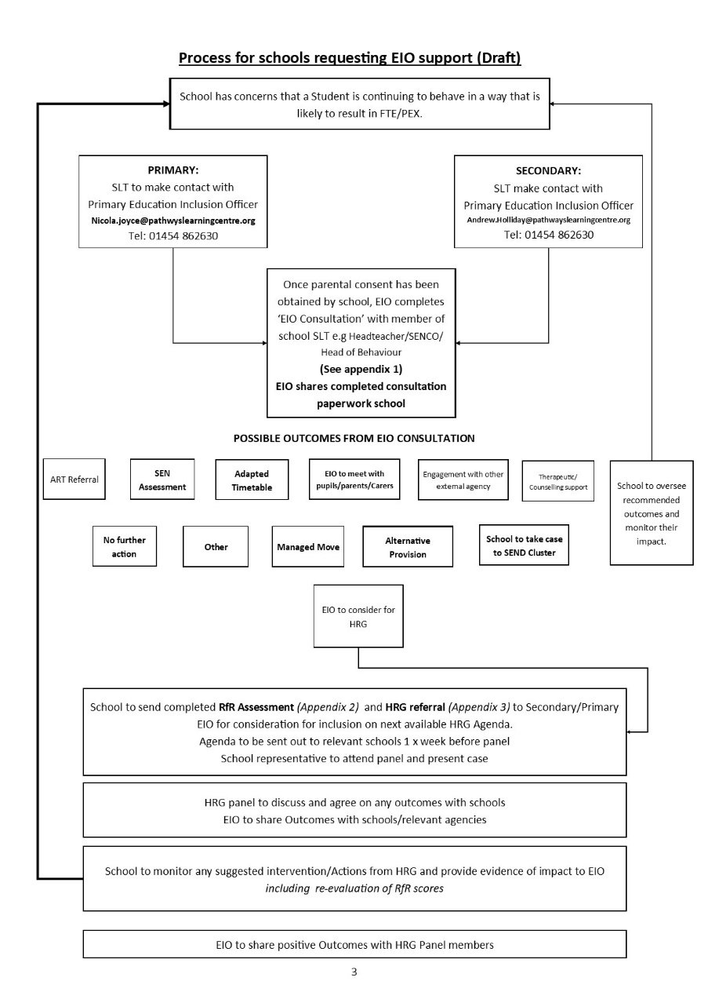

Appendix E – Exclusions Guidelines linked to letters
FIXED TERM  up to and including 5 days in one term  (can be cumulative)  Model Letter 1 | FIXED TERM  adding up to more than 5 days and up to 15 days in one term  (can be cumulative)  Model Letter 2 | FIXED TERM  adding up to MORE THAN 15 days in one term and no more than 45 days in school year  (can be cumulative)  Model Letter 3 | PERMANENT  Model Letter 4
- Immediately inform parents/carers of type and length of exclusion and reasons for exclusion.  - Inform parents/carers of right to make representations to Gov. Body (model letter 1).  - Inform LA and record on SIMs.  - Make arrangements for setting and marking work.  - Make arrangements for a re-integration meeting that plans how future behaviour will be managed (not compulsory but good practice).  - Maintain school exclusions database in order to monitor an aggregate of fixed term exclusions.  - Report exclusions termly to Gov Body. | - Immediately inform parents/carers of type and length of exclusion and reasons for exclusion.  - Inform parents/carers of right to make representations to Gov. Body (model letter 2).  - Inform Gov. Body to arrange meetings between 6th and 50th schools days following exclusion, if parent has requested a meeting.  - Inform LA and record exclusion on SIMS within one school day.  - Make arrangements for setting and marking work for the first 5 days.  - Make arrangements for a re-integration meeting that plans how future behaviour will be managed (not compulsory but good practice).  - Ensure all required documentation is made available to Gov. Body, Parent and LA when required.  - Comply with Gov. Body’s resolution to either decline to reinstate or to reinstate either immediately or by a specific, if Governors so resolve.  - Start/Continue a SAFeH and engage with external agencies and parents/carers as a preventative approach to develop an action plan. Ensure parents/carers & pupil’s views are included in action plans and reviews (not compulsory but good practice).  - Contact h the Education Inclusion Officer (via Pathways Learning Centre) and possible referral to High Risk Group (HRG).  For all fixed term exclusion over 5 days  - Arrange suitable full time education from the 6th day  - Inform parents/carers of arrangements for education during the exclusion | - Immediately inform parents/carers of type and length of exclusion, and reasons for exclusion.  - Inform parents/carers of right to make representations to Gov. Body(Model letter 3).  - Inform Gov. Body to arrange meeting on or before 15th school day – statutory meeting.  - Inform LA (and Home LA if not S. Glos) responsible officer for exclusions via email.  - Make arrangements for setting and marking work for the first 5 days.  - Make arrangements for a re-integration meeting that plans how future behaviour will be managed (not compulsory but good practice).  - Ensure all required documentation is made available to Gov. Body, parent/carer and LA.  - Comply with Gov. Body’s resolution to either decline to reinstate or to reinstate either immediately or by a specific, if Governors so resolve.  - Start/Continue a SAFeH and engage with external agencies as a preventative approach and parents/carers as a preventative approach to develop an action plan. Ensure parents/carers & pupil’s views are included in action plans and reviews (not compulsory but good practice).  - Continue working with the Education Inclusion Officer (via Pathways Learning Centre) and ENSURE there is a referral to High Risk Group (HRG).  For all fixed term exclusion over 5 days  - Arrange suitable full time education from the 6th day (this is the school’s responsibility)  - Inform parents/carers of arrangements for education during the exclusion | - Immediately inform parents/carers of type of exclusion and reasons for exclusion.  - Inform parents/carers of right to make representations to Governing Body (Model letter 4).  - Inform Governing Body to arrange meeting on or before 15th school days.  - Inform LA (and “Home” LA if not S Glos) responsible officer for exclusions via email and phone to inform LA of the PEX and that information has been uploaded via SOFIE.  - Complete a referral to Pathways Learning Centre (if pupil lives in South Glos) without delay to make the appropriate provision from the 6th day. Information to be sent secure (e.g using SOFIE) and a copy to be sent to Exclusions and Licencing team (SOFIE/Local Authority/Ad Hoc/Exclusions and licensing) When notifying PLC, please check with them that the information has been received by telephone.  - Make arrangements for setting and marking work for the first 5 days (If fixed term made permanent start counting again from the date the exclusion is made permanent).  - Ensure all required documentation made available (5 school days before the hearing) to Governing Body, parent/carer and LA, using secure communication.  - Comply with Gov. Body’s resolution to either decline to reinstate or to reinstate either immediately or by a specific, if Governors so resolve.  - Maintain the pupil on the school roll until the parental right to ask for the decision to be reviewed (para. 79 - 82) is exhausted.
Notes: Any reference to page numbers or paragraphs refers to Exclusion from Maintained Schools, Academies and Pupil Referral Units in England – September 2017
- Letters may need to be translated into other languages where the parents/carers first language is not English.
- For all exclusions – if the child loses the opportunity to take a public examination or National Curriculum Test the Governing Body MUST be informed.(Para’s 40, 49, 55, 57 and 62 and Annex A Flowchart of DfE Exclusion Guidance Sept 2017 and Annex B A non-statutory guide for head teachers.)
- Lunchtime exclusion counts as half day.
- A child in the care of the LA (or in voluntary care) should not be excluded without considering alternative options for supporting the pupil and discussion with the LA to ensure suitable alternative full –time provision from Day 1. (summary and Para’s 21, 23-25, 48, 50 and Annex B A non-statutory guide for head teachers DfE Exclusion Guidance Sept 2017).
- At all stages of the process, schools should consider the range of interventions available to meet the behavioural needs of the pupil e.g. SAFeH. Inclusion/Behaviour Support, EP.
- Excluded pupils should be enabled and encouraged to participate at all stages of the exclusion process, taking into account their age and understanding.
- Pupils aged 18 or over have the right to represent themselves instead of parent/carer.
- Any decision to exclude must be made in line with the principals of administrative law i.e. that it is lawful, rational, reasonable, fair and proportionate.
- Governors should not interpret a parent’s acceptance of full-time education off-site as signalling agreement with the Headteacher’s decision to exclude.
Academies – a parent may invite an LA rep to attend a meeting of the Academy’s governing body as an observer and he/she can only make representations with the governing body’s consent.

Appendix F Model letter 1 – Fixed Term Exclusion (up to 5 days/lunchtime exclusion)
From the headteacher/principal of a school notifying a parent of:
- a single fixed period exclusion of 5 school days or fewer and where a public examination is not missed
- a fixed period exclusion which does not take the total of fixed period exclusions to more than 5 in one term;
- a lunchtime exclusion. (Parts 4 - 6 DfE guidance 2017)
(Where a school’s academic year consists of more than 3 terms, then a reference to ‘term’ means the period falling between: 31 December to Easter Monday; Easter Monday to 31 July; or 31 July to 31 December.)

Dear [Parent's Name]
I am writing to inform you of my decision to exclude [Child's Name] for a fixed period of [specify period]. This means that he/she will not be allowed in school for this period. The exclusion begins/began on [date] and ends on [date].
I realise that this exclusion may well be upsetting for you and your family, but the decision to exclude [Child's Name] has not been taken lightly. [Child's Name] has been excluded for this fixed period because [reason for exclusion].
You have the right to make representations about this decision to the governing body. [Child's Name] may also be involved in making representations [Explain how this may happen]. If you wish to make representations please contact [Detail how parent needs to make representations – where and to whom e.g. letter, email or telephone contact to governors/clerk, giving number, email or postal address?]. Whilst the governing body has no power to direct reinstatement and is not required to arrange a meeting with you, they must consider any representations you make and may place a note of their findings on your child's educational record.

[For pupils of compulsory school age only]
You are legally required to ensure that your child is not present in a public place in school hours during this exclusion on [specify dates] unless there is reasonable justification for this. I must advise you that you may be given a penalty notice or prosecuted if your child is present in a public place during school hours on the specified dates and you fail to provide reasonable justification for this.

[For pupils of compulsory school age only]
We will set work for [Child's Name] to be completed during the period of his/her exclusion. [Detail the arrangements for this]. Please ensure that work set by the school is completed and returned to us promptly for marking. [If alternative provision is being arranged during an exclusion of 5 days or less the letter should provide details – when/where it will take place and who to report to on the first day.]

You should also be aware that if you think the exclusion relates to discrimination you can make a claim, to the First Tier Tribunal for disability discrimination (http://www.justice.gov.uk/tribunals/send/appeals) or to a County Court for other forms of discrimination.

The following information may be helpful:
- Statutory guidance on exclusion: http://www.education.gov.uk/schools/pupilsupport/behaviour/exclusion
- The Children's Legal Centre: they aim to provide free legal advice and information to parents on state education matters. They can be contacted on 0808 802 0008 or on http://www.childrenslegalcentre.com/. The advice line is open from 8am to 8pm Monday to Friday, except Bank Holidays and 24th December to the 1st January.
- Include other relevant links for example social care, Ethnic Minority & Traveller Achievement Service or the local parent partnership (www.parentpartnership.org.uk).

[Child's Name]'s exclusion expires on [date] and we expect [Child's Name] to be back in school on [date] at [time]. [There is no requirement to hold a reintegration meeting but it would be good practice to do so – ‘Schools should have a strategy for reintegrating pupils that return to school following a fixed period exclusion, and for managing their future behaviour.’; detail the arrangements for the pupil’s return to school].
Yours sincerely

[Name]
Headteacher

Appendix G – Model Letter 2 – Fixed term Exclusion (6-15 days in one term)
From Headteacher/Principal notifying parent of a single fixed period exclusion of between 6 and 15 days in length or one which would take the total of exclusions in one term to more than 5 and up to and including 15 school days (Parts 4 - 6 DfE guidance 2017)

(Where a school’s academic year consists of more than 3 terms, then a reference to ‘term’ means the period falling between: 31 December to Easter Monday; Easter Monday to 31 July; or 31 July to 31 December.)
Dear [Parent's Name]

I am writing to inform you of my decision to exclude [Child's Name] for a fixed period of [specify period/number of days]. This means that [Child's Name] will not be allowed in school for this period. The exclusion start date is [date] and the end date is [date]. Your child should return to school on [date].

I realise that this exclusion may well be upsetting for you and your family, but the decision to exclude [Child's Name] has not been taken lightly. [Child's Name] has been excluded for this fixed period because [specify reasons for exclusion].

If requested to do so by parents, the governing body must consider the reinstatement of an excluded pupil within 50 school days of receiving notice of the exclusion if a pupil would be excluded from school for more than five school days, but not more than 15, in a single term.
[insert date here — no later than 15 school days from the date the governing body is notified].

[Maintained schools only]
You have the right to attend the meeting, be represented (at your own expense) and also to bring a friend. The head teacher and a representative of the local authority will also be invited to attend and to make representations. [Child's Name] may also be involved in making representations. [Explain how this may happen]

[Academies only]
You have the right to attend the meeting, be represented (at your own expense) and also to bring a friend. The head teacher will also be invited to attend and to make representations. [Child's Name] may also be involved in making representations. [Explain how this may happen] You may invite a representative of the local authority to attend a meeting of an Academy’s governing body as an observer; that representative may only make representations with the governing body’s consent.

If you wish to request the governing body meet to consider this exclusion please contact [Detail how parent needs to make representations – where and to whom e.g. letter, email or telephone contact to governors/clerk, giving number, email or postal address?].

The governing body will make reasonable endeavours to arrange the meeting for a date and time that is convenient to all parties, but in compliance with the relevant statutory time limit of 50 school days from receiving notice of the exclusion. The governing body will circulate any written evidence and information, including a list of those who will be present, to all parties at least five school days in advance of the meeting. You will, whether you choose to make representations or not, be notified by the Clerk to the governing body of the time, date and location of the meeting. Please let us know if you have a disability or special needs which would affect your ability to attend the meeting or to make representations. Also, please inform [Clerk] if it would be helpful for you to have an interpreter present at the meeting.

[For pupils of compulsory school age only]
You are legally required to ensure that your child is not present in a public place in school hours during this exclusion on [specify dates] unless there is reasonable justification for this. I must advise you that you may be given a penalty notice or prosecuted if your child is present in a public place during school hours on the specified dates and you fail to provide reasonable justification for this.

[For pupils of compulsory school age only]
We will set work for [Child's Name] during the [first 5 or specify other number as appropriate] school days of his/her exclusion [Detail the arrangements for this]. Please ensure that work set by the school is completed and returned to us promptly for marking. [If alternative provision is being arranged before day six the letter should provide details of this including when/where it will take place and who to report to on the first day.]

[If the individual exclusion is for more than 5 days - for pupils of compulsory school age only] but provision does not have to be arranged by either the school or local authority for pupils in the final year of compulsory education who do not have any further public examinations to sit.

If alternative provision is being arranged then the following information must be included with this notice where it can reasonably be found out within the timescale; if this information on alternative provision is not reasonably ascertainable by the end of the afternoon session it may be provided in a subsequent notice, but it must be provided without delay and no later than 48 hours before the provision is due to start.

For a fixed period exclusion of more than five school days, the governing body must arrange suitable full-time education for any pupil of compulsory school age. From the sixth school day of the exclusion onwards — i.e. from [specify the date] until the expiry of the exclusion [INSERT NAME OF ALTERNATIVE PROVISION] (School must arrange this and meet costs) will provide suitable full-time education. [Detail the arrangements for this if known at the time of writing; if not known say that the arrangements will be notified shortly by a further letter (without delay and no later than 48 hours before the provision is due to start) - e.g. including the start date for any provision of full-time education that has been arranged for the pupil during the exclusion; the start and finish times of any such provision, including the times for morning and afternoon sessions where relevant; the address at which the provision will take place; and any information required by the pupil to identify the person he / she should report to on the first day.

You should also be aware that if you think the exclusion relates to discrimination you can make a claim, to the First Tier Tribunal for disability discrimination (http://www.justice.gov.uk/tribunals/send/appeals) or to a County Court for other forms of discrimination.

The following information may be helpful:
- Statutory guidance on exclusion: http://www.education.gov.uk/schools/pupilsupport/behaviour/exclusion
- The Children's Legal Centre: they aim to provide free legal advice and information to parents on state education matters. They can be contacted on 0808 802 0008 or on http://www.childrenslegalcentre.com/. The advice line is open from 8am to 8pm Monday to Friday, except Bank Holidays and 24th December to the 1st January.
- Include other relevant links for example social care, Ethnic Minority & Traveller Achievement Service or the local parent partnership (www.parentpartnership.org.uk).

[Child's Name]'s exclusion expires on [date] and we expect [Child's Name] to be back in school on [date] at [time]. [There is no requirement to hold a reintegration meeting but it would be good practice to do so – ‘Schools should have a strategy for reintegrating pupils that return to school following a fixed period exclusion, and for managing their future behaviour.’; detail the arrangements for the pupil’s return to school].
Yours sincerely
[Name]
Headteacher

Appendix H – Model Letter 3 – Fixed term exclusion (15 days or more in one term)
From Headteacher/Principal notifying parent of a fixed period exclusion of more than 15 school days in total in one term (or which brings the pupil’s total number of days of exclusion to more than 15 in one term). (Parts 4 - 6 DfE guidance 2017)

(Where a school’s academic year consists of more than 3 terms, then a reference to ‘term’ means the period falling between: 31 December to Easter Monday; Easter Monday to 31 July; or 31 July to 31 December.)
Dear [Parent's Name]

I am writing to inform you of my decision to exclude [Child's Name] for a fixed period of [specify period/number of days]. This means that [Child's Name] will not be allowed in school for this period. The exclusion start date is [date] and the end date is [date]. Your child should return to school on [date].

I realise that this exclusion may well be upsetting for you and your family, but the decision to exclude [Child's Name] has not been taken lightly. [Child's Name] has been excluded for this fixed period because [specify reasons for exclusion].

The governing body must consider the reinstatement of an excluded pupil within 15 school days of receiving notice of the exclusion if it is a fixed period exclusion which would bring the pupil's total number of school days of exclusion to more than 15 in a term. The latest date on which the governing body can meet is [insert date here — no later than 15 school days from the date the governing body is notified].

[Maintained schools only]
You have the right to attend the meeting, be represented (at your own expense) and also to bring a friend. The head teacher and a representative of the local authority will also be invited to attend and to make representations. [Child's Name] may also be involved in making representations. [Explain how this may happen]

[Academies only]
You have the right to attend the meeting, be represented (at your own expense) and also to bring a friend. The head teacher will also be invited to attend and to make representations. [Child's Name] may also be involved in making representations. [Explain how this may happen] You may invite a representative of the local authority to attend a meeting of an Academy’s governing body as an observer; that representative may only make representations with the governing body’s consent.

If you wish to make representations please contact [Detail how parent needs to make representations – where and to whom e.g. letter, email or telephone contact to governors/clerk, giving number, email or postal address?].

The governing body will make reasonable endeavours to arrange the meeting for a date and time that is convenient to all parties, but in compliance with the relevant statutory time limit of 15 school days from receiving notice of the exclusion. The governing body will circulate any written evidence and information, including a list of those who will be present, to all parties at least five school days in advance of the meeting. You will, whether you choose to make representations or not, be notified by the Clerk to the governing body of the time, date and location of the meeting. Please let us know if you have a disability or special needs which would affect your ability to attend the meeting or to make representations. Also, please inform [Clerk] if it would be helpful for you to have an interpreter present at the meeting.

[For pupils of compulsory school age only]
You are legally required to ensure that your child is not present in a public place in school hours during this exclusion on [specify dates] unless there is reasonable justification for this. I must advise you that you may be given a penalty notice or prosecuted if your child is present in a public place during school hours on the specified dates and you fail to provide reasonable justification for this.

[For pupils of compulsory school age only]
We will set work for [Child's Name] during the [first 5 or specify other number as appropriate] school days of his/her exclusion [Detail the arrangements for this]. Please ensure that work set by the school is completed and returned to us promptly for marking. [If alternative provision is being arranged before day six the letter should provide details of this including when/where it will take place and who to report to on the first day.]

[If the individual exclusion is for more than 5 days - for pupils of compulsory school age only] but provision does not have to be arranged by either the school or local authority for pupils in the final year of compulsory education who do not have any further public examinations to sit.

If alternative provision is being arranged then the following information must be included with this notice where it can reasonably be found out within the timescale; if this information on alternative provision is not reasonably ascertainable by the end of the afternoon session it may be provided in a subsequent notice, but it must be provided without delay and no later than 48 hours before the provision is due to start.

For a fixed period exclusion of more than five school days, the governing body must arrange suitable full-time education for any pupil of compulsory school age. From the sixth school day of the exclusion onwards — i.e. from [specify the date] until the expiry of the exclusion [INSERT NAME OF ALTERNATIVE PROVISION] (School must arrange this and meet costs) will provide suitable full-time education. [Detail the arrangements for this if known at the time of writing; if not known say that the arrangements will be notified shortly by a further letter (without delay and no later than 48 hours before the provision is due to start) - e.g. including the start date for any provision of full-time education that has been arranged for the pupil during the exclusion; the start and finish times of any such provision, including the times for morning and afternoon sessions where relevant; the address at which the provision will take place; and any information required by the pupil to identify the person he / she should report to on the first day.

You should also be aware that if you think the exclusion relates to discrimination you can make a claim, to the First Tier Tribunal for disability discrimination (http://www.justice.gov.uk/tribunals/send/appeals) or to a County Court for other forms of discrimination.

The following information may be helpful:

- Statutory guidance on exclusion: http://www.education.gov.uk/schools/pupilsupport/behaviour/exclusion
- The Children's Legal Centre: they aim to provide free legal advice and information to parents on state education matters. They can be contacted on 0808 802 0008 or on http://www.childrenslegalcentre.com/. The advice line is open from 8am to 8pm Monday to Friday, except Bank Holidays and 24th December to the 1st January.
- Include other relevant links for example social care, Ethnic Minority & Traveller Achievement Service or the local parent partnership (www.parentpartnership.org.uk).

[Child's Name]'s exclusion expires on [date] and we expect [Child's Name] to be back in school on [date] at [time]. [There is no requirement to hold a reintegration meeting but it would be good practice to do so – ‘Schools should have a strategy for reintegrating pupils that return to school following a fixed period exclusion, and for managing their future behaviour.’; detail the arrangements for the pupil’s return to school].
Yours sincerely
[Name]
Headteacher

Appendix I – Model Letter 4 – Permanent Exclusion
From the Headteacher/Principal of a school notifying the parent(s) of a pupil's permanent exclusion. (Parts 4 - 6 DfE guidance 2017)
Dear [Parent's Name]
I regret to inform you of my decision to permanently exclude [Child's Name] with effect from [date]. This means that [Child's Name] will not be allowed in this school unless he/she is reinstated by the governing body.
I realise that this exclusion may well be upsetting for you and your family, but the decision to permanently exclude [Child's Name] has not been taken lightly. [Child's Name] has been excluded because [reasons for the exclusion — include any other relevant previous history].

As this is a permanent exclusion the governing body has a legal requirement to consider the exclusion.

[Maintained schools only]
You have the right to attend the meeting, be represented (at your own expense) and also to bring a friend. The head teacher and a representative of the local authority will also be invited to attend and to make representations. [Child's Name] may also be involved in making representations. [Explain how this may happen]

[Academies only]
You have the right to attend the meeting, be represented (at your own expense) and also to bring a friend. The head teacher will also be invited to attend and to make representations. [Child's Name] may also be involved in making representations. [Explain how this may happen] You may invite a representative of the local authority to attend a meeting of an Academy’s governing body as an observer; that representative may only make representations with the governing body’s consent.

If you wish to make representations please contact [Detail how parent needs to make representations – where and to whom e.g. letter, email or telephone contact to governors/clerk, giving number, email or postal address?].

The governing body will circulate any written evidence and information, including a list of those who will be present, to all parties at least five school days in advance of the meeting. You will, whether you choose to make representations or not, be notified by the Clerk to the governing body of the time, date and location of the meeting. Please let us know if you have a disability or special needs which would affect your ability to attend the meeting or to make representations. Also, please inform [Clerk] if it would be helpful for you to have an interpreter present at the meeting.

[For pupils of compulsory school age only]
You are legally required to ensure that your child is not present in a public place in school hours during this exclusion on [specify dates] unless there is reasonable justification for this. I must advise you that you may be given a penalty notice or prosecuted if your child is present in a public place during school hours on the specified dates and you fail to provide reasonable justification for this.

[For pupils of compulsory school age only]
Alternative arrangements for [Child's Name]'s education to continue will be made.

For the first five school days of the exclusion we will set work for [Child's Name] to be completed during the period of his/her exclusion. [Detail the arrangements for this]. Please ensure that work set by the school is completed and returned to us promptly for marking. [If alternative provision is being arranged before day six the letter should provide details of this including when/where it will take place and who to report to on the first day.]

[Where pupil lives in South Gloucestershire - for pupils of compulsory school age only] but provision does not have to be arranged by either the school or local authority for pupils in the final year of compulsory education who do not have any further public examinations to sit.

For a permanent exclusion, the Local Authority must arrange suitable full-time education for any pupil of compulsory school age from the sixth school day of the exclusion onwards — i.e. from [specify the date] until the expiry of the exclusion. South Gloucestershire Pupil Referral Unit (Pathways Learning Centre) will provide suitable full-time education. [Detail the arrangements for this if known at the time of writing; if not known state that the arrangements will be notified by a further letter (without delay and no later than 48 hours before the provision is due to start) - e.g. the start date for any provision of full-time education that has been arranged for the pupil during the exclusion; the start and finish times of any such provision, including the times for morning and afternoon sessions where relevant; the address at which the provision will take place; and any information required by the pupil to identify the person he / she should report to on the first day.] I have forwarded your details to the Pupil Referral Unit (Pathways Learning Centre) and they will be in touch shortly. They can be contacted on 01454 862630.

[Where pupil lives in a local authority other than the excluding school's local authority - For pupils of compulsory school age only]
For a permanent exclusion, the Local Authority must arrange suitable full-time education for any pupil of compulsory school age from the sixth school day of the exclusion onwards — i.e. from [specify the date] until the expiry of the exclusion. I have also today informed [name of officer] at [name of local authority] (e.g. Clare Dudley, Bristol LA) of your child's exclusion and they will be in touch with you about arrangements for [his/her] education from the sixth school day of exclusion. You can contact them at [give contact details].
You should also be aware that if you think the exclusion relates to discrimination you can make a claim, to the First Tier Tribunal for disability discrimination (http://www.justice.gov.uk/tribunals/send/appeals ) or to a County Court for other forms of discrimination.

The following information may be helpful:
- Statutory guidance on exclusion: http://www.education.gov.uk/schools/pupilsupport/behaviour/exclusion
- The Children's Legal Centre: they aim to provide free legal advice and information to parents on state education matters. They can be contacted on 0808 802 0008 or on http://www.childrenslegalcentre.com/. The advice line is open from 8am to 8pm Monday to Friday, except Bank Holidays and 24th December to the 1st January.
- [Include other relevant links for example social care, Ethnic Minority & Traveller Achievement Service or the local parent partnership (www.parentpartnership.org.uk).]
Yours sincerely

[Name]
Headteacher

Appendix J – Model Letter 5 - From the Governing Body of a school notifying a parent of its decision not to reinstate a pupil
From the Governing Body of a school notifying a parent of its decision not to reinstate a pupil (i.e. to uphold the head’s decision to permanently exclude the pupil). (Part 6 DfE guidance 2017)

(Please forward a copy of this letter to the LA; and also to Neil Young (Democratic Services) for information)

Dear [Parent's Name]

The meeting of the Governing Body at [Name of school] on [date] considered the decision by [Head’s Name] to permanently exclude your [son/daughter Name]. The governing body, after carefully considering the representations made and all the available evidence, has decided to uphold the permanent exclusion of [Name of Pupil].

The reasons for the governing body's decision are [Insert reasons in sufficient detail to enable all parties to understand why the decision was made].
……………………………

You have the right to ask for this decision to be reviewed by an independent review panel. If you wish to make an application for a review of the Governing Body’s decision you will need to do so no later than [day and date – i.e. 15 school days plus 2 school days from the date of the letter when posted by 1st class post; ‘Notice is deemed to have been given on the same day if it is delivered directly, or on the second working day after posting if it is sent by first class mail’.]. If you make an application for a review after this date it will be rejected by the local authority.

The application should be made to
Neil Young, Principal Democratic Service Officer
South Gloucestershire Council
Chief Executive & Corporate Resources Department
PO Box 1953
Bristol
BS37 0DB

Please inform Neil Young if you have a disability or special needs which would affect your ability to attend the hearing or if it would be helpful for you to have an interpreter present at the hearing. [For an Academy that does not trade with Legal Services, details and address of own provider which the parent should contact if they wish to request an independent review, should be inserted in place of Neil Young.]

The role of the independent review panel is to review the Governing Body’s decision not to reinstate a permanently excluded pupil. The panel can decide to:
- Uphold the exclusion decision
- Recommend that the Governing Body reconsiders their decision; or
- Quash the decision and direct that the Governing Body considers the exclusion again

Any application should set out the grounds on which it is being made and that, where appropriate, this should include a reference to how the pupil’s special educational needs are considered to be relevant to the exclusion. You have the right to require the Local Authority to appoint a SEN expert to attend the review regardless of whether your child has recognised special education needs; there would be no cost to you for this. The role of the SEN expert is to provide impartial advice to the independent review panel on how special educational needs might be relevant to the exclusion. You must make it clear in your application for a review whether you wish for a SEN expert to be appointed.

You may, at your own expense, appoint someone to make written and/or oral representations to the independent review panel. You may also bring a friend to the review.

In addition to your right to apply for an independent review panel, if you believe that the exclusion has occurred as result of discrimination then you may make a claim under the Equality Act 2010 to the First-tier Tribunal (Special Educational Needs and Disability) in the case of disability discrimination, or the County Court in the case of other forms of discrimination. A claim of discrimination should be lodged within six months of the date on which the alleged discrimination took place e.g. the day on which [Name of Pupil] was excluded.

The following sources of free and impartial information will allow you to make an informed decision on whether and how to seek a review of the Governing Body’s decision:
- Department for Education guidance - Exclusion from maintained schools, academies and pupil referral units in England https://www.gov.uk/government/uploads/system/uploads/attachment_data/file/630073/Exclusion_from_maintained_schools__academies_and_pupil_referral_units_guidance.pdf
- Guidance on making a claim of discrimination to the First-tier tribunal – http://www.justice.gov.uk/tribunals/send/appeals
- the Coram Children’s Legal Centre – www.childrenslegalcentre.com , they can be contacted on 0808 802 0008
- [Also include where considered relevant by governing body – contact details for Traveller Education Services (EMTAS) or Supportive Parents for SEN pupils]

If you do not intend to make an application for a review of this decision you may confirm this in writing to me, but please note, once the Governing Body has received your decision not to apply for a review the head teacher will remove your child’s name from the school register.

Yours sincerely

[Name]
Chair/Clerk to the Governing Body

