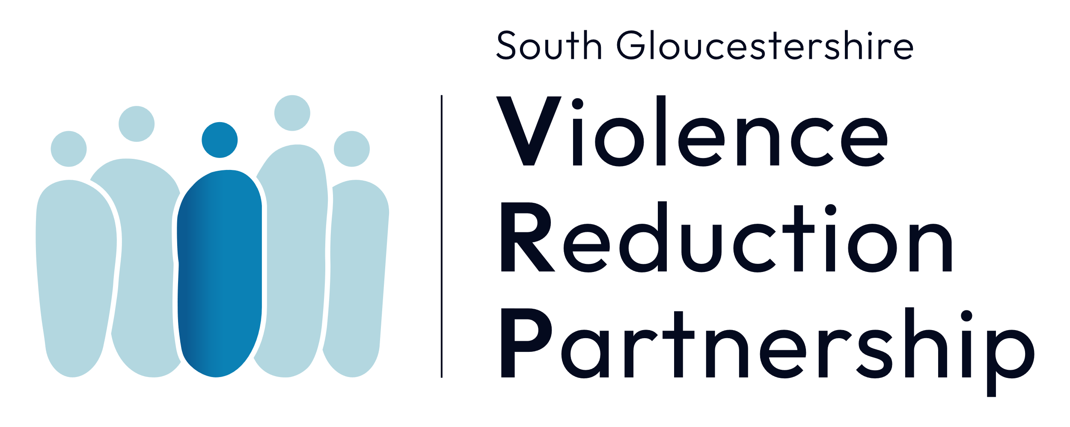

SOUTH GLOUCESTERSHIRE COUNCIL
RISK MANAGEMENT PATHWAY

PARTNERSHIP INTELLIGENCE MANAGEMENT MEETING PROCEDURAL DOCUMENT

DECEMBER 2022

PURPOSE
This is a procedural guide for the Partnership Intelligence Management Meeting (PIMM) as a part of the process for managing extra familial harm. This sits in the wider Risk Management Pathway across South Gloucestershire Council.
INTRODUCTION
Work within the safeguarding arena, specifically around young people, has identified that the traditional methodology of dealing with risk, where it is outside of the family home, and therefore not presented by either parent/carer or guardian, is not so well suited to the standard child protection arrangements. This is particularly the case where parents and carers are showing protective responses to risks and doing as much as is within their ability at that time to keep a child safe.
The risks young people face during adolescence, compared with those faced by younger children, are more likely to be situated outside of the home environment and in public places where young people socialise. These extra-familial threats might arise at school and other educational establishments, from within peer groups, or more widely from within the community and/or online. Sexual exploitation, criminal exploitation, radicalisation, trafficking, and peer on peer violence (gang involvement) - where parents/carers are not perpetrators/ involved in the exploitation of the young person, are examples of extra-familial harms that young people may suffer.
For South Gloucestershire this has led to a review of the way in which community-based harm is managed and coincides with the introduction of Violence Reduction Partnerships across the Avon and Somerset Constabulary area.
The Risk Management Pathway has been designed, (Appendix A) which will assist in identifying the level of risk to a child, whether it is familial or extra familial, and therefore which intervention is the most suitable.
As part of that process is the Partnership Intelligence Management Meeting (PIMM).
WHAT IS THE PURPOSE OF THE PIMM?
The purpose of the Partnership Intelligence Management Meeting is to:
- Ensure the earliest possible identification of; young people who may be at risk of extra familial harm; possible people of interest; locations, emerging issues or hotspots.
- Ensure that young people are supported at the earliest opportunity and at the right level to respond to the level of risk/need. This will include signposting active cases to lead professionals and ensuring referrals to children’s social work service are made where there is known or suspected significant harm.
- Ensure that information and intelligence is shared across partner agencies to develop an understanding of themes, emerging trends, and links between a number of young people, possible perpetrators and locations/ places where young people may be experiencing extra familial harm.
The PIMM will take place fortnightly and will be chaired by the South Gloucestershire Violence Reduction Partnership. The meetings will have a vice chair from the Police. The agenda for each meeting will be set by the chair.

Core membership for the PIMM will consist of representatives from:
- Strategic Safeguarding, South Glos Local Authority
- Operational Children’s Social Care, South Glos Local Authority
- YPS (Young People’s Support), South Glos Local Authority
- Education, South Glos Local Authority
- MASH health (Sirona Care)
- Violence Reduction Partnership, South Glos Local Authority
- Avon and Somerset Police VRP Team
- Youth Justice Service Team, South Glos Local Authority
- BASE (Barnardos Against Sexual Exploitation)
- Young People’s Drug and Alcohol Service, South Glos Local Authority
- Education Safeguarding Advisor
- Avon and Somerset Police ASB Team
- Avon and Somerset Police Missing Person’s Co-ordinator
- Avon and Somerset Police Op Topaz Representative
- Consultant Social Worker, South Glos Local Authority
- VRU Commissioned Services working with young people.

HOW WILL IT WORK?
Information/ intelligence will be brought and shared by all core members regarding emerging concerns about children or young people, possible perpetrators and locations/ hotspots and trends linked to extra familial harm of young people in South Gloucestershire.
This information/ intelligence will come from a number of sources for the two-week period prior to the meeting including from police missing persons reports, from the VRP app and other VRP data, from Topaz multi agency meetings, allocated social work staff, Police ASB team and the Education High Risk Group meetings. The PIMM will manage and monitor a cohort based upon risk.
Actions will be agreed at the meeting which may include.
- The need for a mapping exercise to understand links/ associations.
- Information to be shared with organisations e.g. about a location identified as of concern.
- Referrals for individual young people e.g. Children’s Social Care, YPDAS, BASE etc.
- The need for a Complex Risk Management Meeting in the case of concerns about a group of young people being exploited.
All agreed actions will be reviewed at the subsequent meeting and thereafter. Any action plan relating to a community/location will be subject to the same review.
The cohort discussed as a result of the information sharing from professionals will be subject to three tiers, based upon identified or perceived risk;
Tier One – those who are deemed to be at the most significant risk and require immediate intervention and support – (Red rating).
Criteria for Tier One entry should include, but is not be limited to;
- Information or intelligence that points to an immediate risk of harm.
- That the information/intelligence can be supported or corroborated.
- Rapid escalation of, or entry into, crime or exploitation.
- Risk identified across multiple partners.
In this case a lead professional should be identified or already be in place in order to co-ordinate action.
Tier Two – those where risk is identified but requires further investigation to identify support or intervention themes – (Amber rating).
Criteria for Tier Two should include.
- Information or intelligence that points to a risk of harm that is not immediate.
- The information or intelligence requires further investigation.
- Exploitation is suspected but as yet no associated crime or disorder.
- Single partner referral and therefore requires cross partnership investigation.
Expectation is that a lead professional should be appointed to oversee the progress of the individual or cohort.

Tier Three – those where there may be limited or negligible risk of harm and require monitoring for future incidents/intelligence – (Green rating).
Criteria for Tier Three should include;
- Information or intelligence which is third hand and cannot be in any way corroborated.
- Single partner referral and not known to any other agency/partner.
- Information or intelligence is not capable of being progressed for further investigation to identify risk.
- No obvious signs of exploitation or crime but indicators that something may be amiss such as out of character first missing episode/associated with another who may be known to PIMM.

It is fully expected that individuals within the Tiers will move up and down dependent on risk factors and possible harm requiring a more or less intensive level of support and intervention.
When PIMM has been able to effect change and therefore reduce or negate the level of risk to a point where it can no longer be identified or appropriate long term support is in place, then the young person will be removed from the PIMM cohort.
In the case of perpetrators, the PIMM will aim to gather as much information as is possible to support law enforcement agencies with disruption. This could include the use of criminal legislation towards arrest, civil legislation with injunctions or even Anti-social Behaviour legislation with the deployment of Community Protection Warning/Community Protection Notice or Criminal Behaviour Order for example.

CASE MANAGEMENT AND ADMINISTRATION
The PIMM will be administered with the assistance of a Technical Admin Support Officer from within the Safer Stronger Communities Team. That individual will assist with scheduling meetings, taking the minutes and circulation of information to partners.
Minutes and items relating to individuals will initially be captured on a working document, and lead professionals will be tasked with ensuring the transference of information to a substantiated record within either the Mosaic database and/or that of Niche for the Police, or Uniform for the Community Safety Team.
All information captured at PIMM will be stored securely within the Safer Stronger Communities secure folder which is a protected resource.
WHAT WILL THE GOVERNANCE BE?
As part of the new Risk Management Pathway the PIMM will be subject to supervision and governance from the Extra Familial Harm Multi-Agency Strategic Panel.
This will be made up of senior managers from Safer Stronger Communities, Integrated Children’s Services, Clinical Commissioning Group, Public Health and Avon and Wiltshire Partnership.
Ultimately actions and processes completed within the entire Risk Management Pathway are the subject of scrutiny from The Children’s Partnership, formerly the Children’s Safeguarding Board, and from the Community Safety Partnership who oversee all things related to community safety, crime and disorder.

Appendix A – Risk Management Pathway Flow chart
