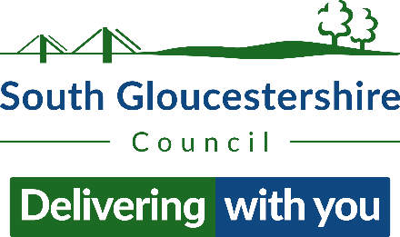
Children and Young People Domestic Abuse Support Referral Form

Overview of Service
Service providing 1:1 and/or group support to children and young people (5-16yo) effected by domestic abuse.
- Support to understand and process experiences and focus on simple cues of safety and regulation.
- Help with representative safety planning and relevant risk assessment.
- Empowerment to improve confidence, self-esteem and wellbeing.
-

*For more information, please see relevant information sheet.

Before making a referral into our service, please see the following and cross to agree…

- The child or young person is of or between the ages of 5-16 years old. |  | ☐
- The child or young person has experienced domestic abuse directed towards themselves or has been present in a household where domestic abuse has occurred (emotional, physical, material, financial). |  | ☐
- The child or young person lives within the county of South Gloucestershire. |  | ☐
- The child or young person is currently being supported by South Gloucestershire Children’s Services and is on a plan.  Please cross as applicable… | Looked After Child | ☐
 | Child In Need Plan | ☐
 | Child Protection Plan | ☐
 | Early Help Plan | ☐
 | Discussed at MARAC | ☐
- The child or young person is aware of what this support will consist of, has agreed to the referral that is being made on their behalf, and all other relevant consent has been gained. |  | ☐
- The child or young person is not currently living in a safe house or refuge accommodation. |  | ☐

*Please note, if any of the above fields remain unmarked the referral will be declined - please see flow chart for alternative provision.
Child or Young Persons Details

Full Name: |  | Preferred Name:
Gender:

Ethnicity:

Date Of Birth: |  | Age:
Home Address: |  | Postcode:
School/ College:

Preferred Meeting Place/ Time:
Additional Needs?

Referrer Details

Name of Referrer:

Role/ Job Title:

Referring Agency:

Phone Number:

Referrers Email:

Details of Parent/ Main Carer

Full Name:

Relation to CYP:

Home Address: |  | Postcode:
Email: |  | Safe to Contact? | Yes/No
Phone Number: |  | Safe to Contact? | Yes/No

Context surrounding Domestic Abuse

Date(s):

Full Name of Perpetrator(s):
Perpetrators Address (if known): |  |  | Is the perpetrator living in the same household? |  | Y/N
Brief Description of the Domestic Abuse:

Desirable Outcomes from Support:

Please Indicate Preference: | Group Programme ☐ | 1:1 Support ☐ |  | Combination ☐

*Any questions or queries, please go ahead and email DAsupportCSC@southglos.gov.uk

