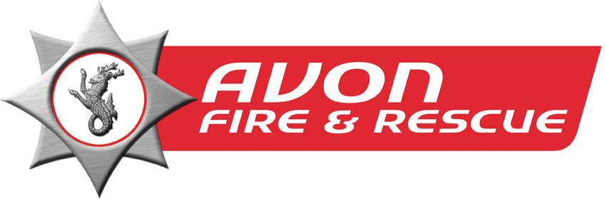

YOUNG PEOPLE’S EDUCATION:

The aim of the young people’s education programme is to reduce the risk of fire, road traffic collisions (RTCs) or special service calls through providing education and raising awareness, targeting priority areas.

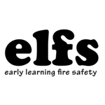
Elfs is an exciting, fun filled box that has been developed by Cornwall Fire and Rescue Service to provide teachers with the necessary resources to educate children with key skills in safety. The resource includes a teacher’s pack, books, games and other exciting learning materials.
It is designed specifically for educators who work with children aged between 3 and 5 years to promote a healthy and positive awareness of the fire and rescue service and the role of the fire fighter whilst encompassing key learning areas within the EYFS (Early Years Foundation Stage).
To book an elfs pack please fill out the online request form from: http://www.avonfire.gov.uk/avon/index.php?option=com_content&view=article&id=983&Itemid=499

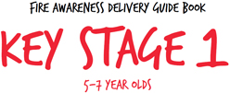
In the UK an average of 34 children under the age of 11 are killed in fires every year and around 1,200 are injured.
We are committed to providing fire safety education to young people to help them stay safe. One of the ways we do this is by visiting schools to deliver lessons about the dangers of playing with fire, hoax calls and fire safety in the home.
We are pleased to introduce our Key Stage 1 package. If you would like to find out more about how we deliver this package please download the pdf guides from: http://www.avonfire.gov.uk/our-services/educational-services?id=201
You can request a school visit by completing the form from the link above providing your invitation reference number if you have received one from us.
Part of the form asks for details about the pupils in the class. We will use this information to tailor our lessons to the needs of the class, taking into consideration any special requirements, and to monitor our delivery and evaluate our progress.

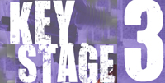
The KS3 FiRE (Fire & Risk Education) session has been designed with the National curriculum to provide an interactive learning platform that enables 11-14 year olds to gain a deeper understanding of fire and risk taking. The session is focused on risk taking behaviours, consequences of fire setting and escape plans.

Wrecked presentation: This is a road safety session delivered together with fire crews and the road safety partnership. The ‘Wrecked’ resource has been designed to encourage discussion amongst young people on the causes, consequences and alternative outcomes of road incidents and is aimed at 16-24 year olds (key stage 4). Each session involves playing a number of short story clips which give the account of various local road incidents, told by the individuals that were involved. After each clip, the facilitator then leads the group in peer-to-peer discussion and activities.

FIRE SETTERS SCHEME:

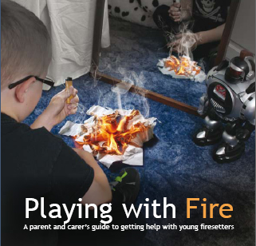
The programme is aimed at children and young people who have problems associated with fire play or fire setting. The aim of the scheme is to raise the child's awareness of the dangers of fire and the results of their actions.

Requests for help come from various sources, including parents, schools, Children and Young people Services (CYPS), AF&RS staff, the police, NHS and others.

Parental agreement and support is crucial to the success of the programme and each session is tailored to the needs and abilities of the child concerned. The programme maintains confidentiality unless we have a legal responsibility to pass information on to other agencies, in which case we will discuss our actions with the family.
When to make an referral to the firesetters
Any incident where:
- A young person aged under 25 years of age has displayed fire setting behaviour.
- A young person has been involved in making a hoax call.
- A young person needs reassurance from AF&RS with regard to their feelings about fire
How to make a referral
- By phone: 0117 926 2061 (extension 393 - voicemail)
- By emailing Firesetters@avonfire.gov.uk
- By filling out the online form from: http://www.avonfire.gov.uk/safety-advice/advice-for-parents/firesetter

Safety advice & Home Fire Safety

Fires in the home are devastating, but most of the incidents we are called to could have been avoided.
Through Home Fire Safety Visits we provide practical advice and education to prevent fires starting in the first place.
Anyone can request a free visit where a member of our staff will come to your home to provide you with information about how to reduce the risk of a fire starting.
The help we offer will be specific to your circumstances and will include advice on
- Escape routes
- Cooking safety
- Electrical safety
- A night time routine
- What to do if there is a fire
Smoke alarms will also be fitted free of charge if needed.
You can request a free Home Fire Safety Visit for yourself or on behalf of a friend or loved one by filling out the form from: http://www.avonfire.gov.uk/our-services/home-fire-safety-visits
Or calling us on 0117 926 2061

Further advice for parents and teachers can be found at: http://www.avonfire.gov.uk/safety-advice/advice-for-parents

