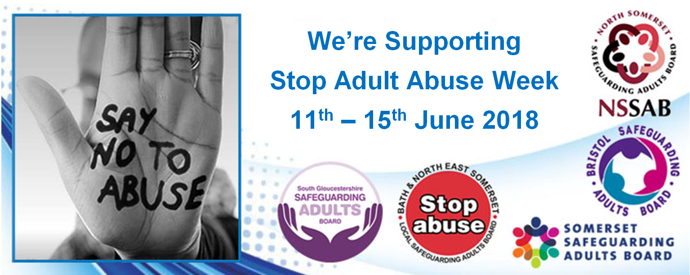

Stop Adult Abuse Week Resource and Promotion Pack
11th – 15th June 2018

This pack is designed to give agencies resources to get involved with Stop Adult Abuse Week by running a number of promotional activities to raise awareness of how to prevent and stop adult abuse. Agencies can also come up with their own ideas; if you do we would love to hear about them so we can improve Stop Adult Abuse Week in the future.
Stop Adult Abuse Week is a local initiative that started in 2014 when a number of Local Safeguarding Adult Board Communications Groups in the South West decided to join together to run a week to focus attention on Safeguarding. Each area chose a week to run a series of communications and events to promote safeguarding called Stop Adult Abuse Week. Now in its third year we have learnt that small local events work better than public stalls. We have also identified that providing materials gathered from good practice over the last two years will help agencies to get involved.

Sent out with this pack is a Safeguarding Wordsearch and separate answers sheet that can be used within staff teams to raise awareness and discussion. the answers are not included below in the embedded document so that teams do not inadvertently gain the answers when the pack is disseminated!

Monday 11th June Think Family led by Bath and North East Somerset
The theme for Monday 11th June Stop Adult Abuse Week is Think Family. You can help promote the Think Family approach to prevent and identify adult abuse by your agency taking part in Stop Adult Abuse Week.
Here are some ideas about how you can promote the Think Family approach on Monday 11th:
- Run safeguarding training for staff or service users on the Think Family agenda that week using this PowerPoint presentation .
- Send round information on safeguarding to service users or staff that week.
- Promote safeguarding messages to staff, service users and the public via the #stopadultabuseweek on Twitter, on other social media, It can be difficult to think of Twitter messages here are three you could send
- #stopadultabuseweek Think family – many members of a family can be vulnerable to abuse – watch this video to find out more
- #stopadultabuseweek Think family – if you know a family member is caring for a loved one and is struggling call ASIST on 01225 396000 to get help.
- Use the picture with #stopadultabuseweek
- Promote safeguarding messages to staff, service users and the public via ebulletins, newsletters intranet, payslips, send the Local Safeguarding Adult Boards newsletter etc.
- Have the safeguarding banner or leaflets at events you are running that week. Contact your Local Safeguarding Board Lead.
- You could send a link to the Think family video through this URL https://www.youtube.com/watch?v=cSoBG9B1XnY part 1 and https://www.youtube.com/watch?v=Nnbwq_wHH2k part 2.
- Use the joint ‘We’re supporting stop adult abuse week’ picture as an email footer for the week with links to Think Family resources.
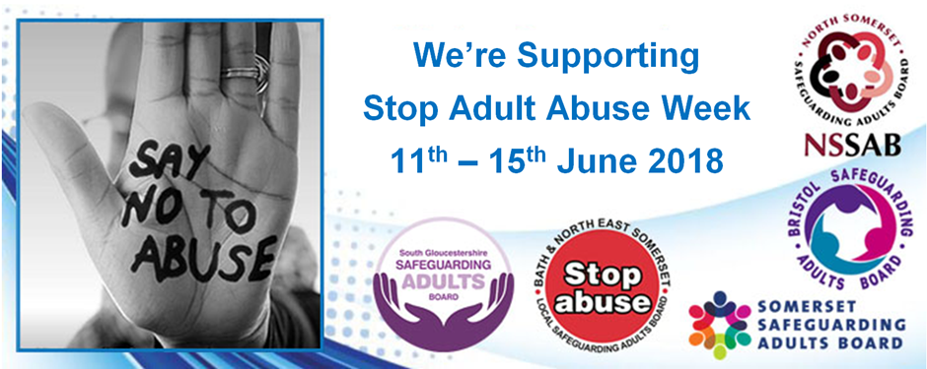
- Share resources with your staff to help them make connections between forms of abuse and how they show up in families
  - Domestic abuse is perhaps most commonly thought of as violence between intimate partners, but it can take many other forms and be perpetrated by a range of people. Much safeguarding is therefore also domestic abuse. This guide sets out the overlaps between safeguarding and domestic abuse and the approaches and legal frameworks for domestic abuse that can be used in the safeguarding context. https://www.local.gov.uk/sites/default/files/documents/adult-safeguarding-and-do-cfe.pdf
  - This review paper looks at the evidence and practice around carers and safeguarding. Carers usually strive to act in the best interests of the person they support. There are times, however, when carers themselves experience abuse from the person to whom they are offering care and support or from the local community in which they live. Risk of harm to the supported person may also arise because of carer stress, tiredness, or lack of information, skills or support. Sadly, also, there are times where harm is intended. Sometimes, professionals may place undue confidence in the capacity of families to care effectively and safely. This is coming to be known as “the rule of optimism”. We need to keep it in mind. This paper encourages greater information and knowledge exchange; identifies areas for learning, for empowerment and ensuring carers are recognised, listened to and respected by skilled and competent staff when concerns arise. http://static.carers.org/files/carers-and-safeguarding-document-june-2011-5730.pdf

Tuesday 12th June Mate Crime led by Bristol
Things you can do in your service to help people to become more aware of Mate Crime are:
- Add the banner to your email address for the week
- Talk to people about mate crime and explain what a true friendship looks like. We have produced a leaflet to support you
- Attend the conference at BAWA – if you cannot attend you can ask BSAB for a copy of the power-point presentations by emailing bsab@bristol.gov.uk
- Show your support to highlight Mate Crime and promote ‘Stop Adult Abuse Week’ through social media. Some possible tweets could include:
- Mate crime is done by someone you know #stopadultabuseweek
- Sometimes people pretend to be your friend online when they are just trying to scam you #stopadultabuseweek
- A mate doesn’t always expect you to pay #stopadultabuseweek
- A mate doesn’t bully you #stopadultabuseweek
- A mate doesn’t hurt you #stopadultabuseweek
- A mate doesn’t make you do things you don’t want to do #stopadultabuseweek

- A mate doesn’t have parties and ruin your house #stopadultabuseweek
- A mate doesn’t use all the credit on your phone #stopadultabuseweek
- A mate doesn’t eat all your food #stopadultabuseweek
- A mate doesn’t take your stuff #stopadultabuseweek
- Mate crime is a disability hate crime –report it! #stopadultabuseweek
- You don’t need evidence to report just a real concern #stopadultabuseweek
- If someone lives in fear of someone, they may be being abused #stopadultabuseweek
- Safeguarding adults is about looking after adults who could be vulnerable. #stopadultabuseweek

Coercion led by North Somerset Council:
Coercion is the practice of forcing another person to act in an involuntary manner by use of threats or force.
It is a violation of the free will of the victim to gain a desired response, for example: a bully demanding lunch money from a student or the student gets beaten.
These actions may include, but are not limited to: extortion, blackmail, torture, threats to induce favours, or even sexual assault.
Such actions are used as leverage, to force the victim to act in a way contrary to their own interests.
On Monday the focus will be coercion and Domestic Abuse. There will be a brief explanation of what is meant by Domestic Abuse, the impact of Domestic Abuse and how children can be affected. It will also include some of the contact numbers of the help and support available.
On Wednesday the focus will be coercion and Modern Slavery; including clarification of what is meant by Modern Slavery, who can be victims of Modern Slavery and the contact numbers of the help and support available.
On Friday the focus will be on the information from the Safeguarding Adults Review for Mendip House. It will include some of the concerns raised, lessons & conclusions, and the contact number to raise a concern.

What Is Coercive Control?
https://www.domesticshelters.org/domestic-violence-articles-information/what-is-coercive-control#.WvGaVT- Wy1s

Word Search from Women’s Aid
http://www.thedrum.com/creative-works/project/wcrs-women-s-aid-mind-games#&gid=1&pid=1
Resources for Families
https://www.thisisnotanexcuse.org/friends-and-family/
https://www.thisisnotanexcuse.org/wp-content/uploads/2015/09/Domestic-Abuse-Friends-and-Family-Help-Guide-1.pdf
Resources for professionals:
This series of five fictional case studies have been produced using the principles of evidence-informed practice. This means using a mixture of:
- The research evidence about the experience of domestic abuse and coercive control for that group
- Practitioner experience of similar cases
- The voice of people who use services, using quotes from the research.
The case studies are a learning tool. They aim to promote reflection on practice when working with people experiencing coercive control.
Each case study includes:
- The case details, summarising the situation and asking how you would make a safe enquiry
- A partly completed assessment, with space for you to add your own analysis and critically reflective conclusion
- An example of a completed assessment and safety plan, to prompt discussion and debate
- A completed DASH- RIC, and a blank one with guidance attached for you to fill out
- A set of topics related to the case study; these signpost to research and tools for practice which relate to the themes in the case study
- 3 practice tools, again drawing on the case study tools
- References and further reading.
You can pick and mix these with the other resources to create learning materials within your own organisation.
Case Studies available here
Useful Links:
http://www.nationaldomesticviolencehelpline.org.uk/
https://www.iriss.org.uk/resources/insights/domestic-abuse-and-child-protection-womens-experience-social-work-intervention?gclid=CjwKCAjwlcXXBRBhEiwApfHGTdnyBrHgW7L0QJtWjBbL9C4VX46xvO4lxL7g6-DUglGYPw_N7MF2hxoCZ64QAvD_BwE
https://www.avonandsomerset.police.uk/newsroom/features/abuse-isn%E2%80%99t-always-physical/
https://www.thisisnotanexcuse.org/

STOP ADULT ABUSE WEEK

MONDAY 11th to FRIDAY 15th JUNE 2018
Safeguarding Adult Review (SAR)
Mendip House January 2018:

Some of the concerns raised:  A resident would flinch in the presence of a certain staff member.  A staff member made a resident crawl around on all fours.  Staff threw cake at a resident’s head and put crayons in their coffee. When the resident asked for a biscuit they were given an onion and sent to their room when they wouldn’t eat it.  A resident was offered cake then the staff member took it away.  Staff members threw cake at a resident. The resident spilt their tea over them self. | Lessons & Conclusion:  The staff at the home engaged in behaviour that was cruel and far below the standard expected.  The sheer number of consistent allegations… and acceptance that there was a “laddish culture” at the home led the author of the SAR to conclude that the incidents happened.  The office was messy and disorganised… consideration should be given to how audit and supervision processes might be tightened.  A resident’s review was abandoned in November 2015 because of the inadequacy of the documentation.  It highlighted the need for regular reviews and making regular contact with the residents by the placing authority. However, if a review has not taken place the placing authority needs to alert the host authority.

Based on the information in Mendip House SAR: staff members whose role was to support and encourage the residents, abused their position of trust by bullying them

STOP ADULT ABUSE WEEK
MONDAY 11th to FRIDAY 15th JUNE 2018
Domestic Abuse:  What is Domestic Abuse?  Domestic abuse is defined as controlling, coercive or threatening behaviour between partners or family members who are aged over 16.  It is not just physical violence it can include threats, emotional, sexual or financial abuse.  Domestic abuse is very common but many people experiencing it do not ask for help.  There is support available for anyone living with domestic abuse; including helplines, one-to-one support, courses and drop-ins. |  | The impact of Domestic Abuse?  The long-term impact of any domestic abuse can be devastating. People who experience Domestic Abuse may suffer many ill effects including injuries, fear and low self-esteem.  It is the leading cause of ill health for women of childbearing age, having a particularly adverse impact upon their mental health.  Children can be affected by Domestic Abuse: Domestic abuse can affect the well-being of children who live with it. They may be directly affected by being injured whilst getting in the way of an assault or having to move to a refuge. They may also be emotionally affected by hearing the assault. The impact upon a child of living with domestic abuse may continue into adulthood without the right support.
Help and Support Available:
If you are in immediate danger, contact the police on 999
 | - DAFFS Support Line (Local Helpline): |  | 0800 694 9999
 | 09.00 to 18.00 weekdays. This will be answered by a local domestic abuse specialist.
 | - National LGBT & Domestic Abuse Helpline: |  | 0800 999 5428
 | support for lesbian, gay, bisexual and transgender people experiencing domestic abuse
 | - Respect: |  | 0808 802 4040
 | Information and advice for anyone who is abusive to their partner
 | - MALE advice line (National Helpline): |  | 0808 801 0327
 | Support for men experiencing domestic abuse
 | - Women’s Aid/Refuge (National Helpline): |  | 0808 2000 24
 | 24hr helpline for women in abusive relationships
 | - www.endabuse.org.uk
 | website signposting support available on domestic abuse in the UK
 | - www.thehideout.org.uk
 | Website created by Women's Aid to help children and young people understand domestic abuse, and how to take positive action if happening to them.
 | - This is not an excuse - local domestic abuse website Helpline 0800 6949999
 | - B&NES Domestic Abuse Information including counselling for Polish residents - click here

STOP ADULT ABUSE WEEK

MONDAY 11th to FRIDAY 15th JUNE 2018
Modern Slavery:  What is Modern Slavery?  Modern Slavery is the illegal exploitation of people for personal or commercial gain.  Victims are trapped in servitude, which they were deceived or coerced into, and feel they cannot leave.  It includes human trafficking where someone has been moved into a situation of exploitation using deception, coercion or violence.  Common forms of exploitation include; domestic servitude, sexual exploitation, forced marriage, forced criminality, and forced labour.  The Home Office estimated that there were between 10,000 and 13,000 potential victims of modern slavery in the UK in 2013. While this is only an estimate, it highlights the shocking extent of this crime and the scale of the challenge. | Victims of Slavery:  Victims can be of any age, gender, race or nationality.  Victims all have something that makes them vulnerable to exploitation.  This can include; poverty, drug addiction, learning disability, mental health, homelessness and social exclusion.  Victims of Modern Slavery are often:  - forced to work; through mental or physical threat.  - owned or controlled by an ‘employer’, usually through mental or physical abuse or the threat of abuse.  - treated as a commodity or bought and sold as ‘property’.  - physically constrained or have restrictions placed on their freedom of movement.
Help and Support Available:
- If the victim is in immediate danger, contact the police on 999

- If you have any suspicion that someone could be a modern slave or you want help or advice call the Modern Slavery Helpline on 08000 121 700

- To report suspicious behaviour, you can call the local police on 101

- You can make an anonymous call to Crimestoppers on 0800 555 111.

- If you are worried about a child, call the NSPCC helpline 0808 800 5000

Stop Adult Abuse Week 2018 - Somerset
General
We will post proportional posts on social media each day directing people to the SAB that is focusing on that day
Focus – care and support providers:
- Learning from serious cases – we will promote practice learning from this page of our website - http://ssab.safeguardingsomerset.org.uk/about-us/publications/learning-from-serious-cases/-

- Spotting the signs, symptoms and indicators of abuse – we will promote information for each of the 10 types of abuse

- Information on what makes a good/poor referral (to follow)

- Information on how to Recognise, Respond, Record and Report abuse (see attached posts)

- Presentations from our recent conference - http://ssab.safeguardingsomerset.org.uk/about-us/publications/ssab-conferences/

- Our risk threshold tool http://ssab.safeguardingsomerset.org.uk/wp-content/uploads/2016/04/Adult-Safeguarding-Risk-Threshold-Tool.pdf

- Our service monitoring http://ssab.safeguardingsomerset.org.uk/wp-content/uploads/SSAB-Service-Monitoring-Checklist-1.pdf

SAFEGUARDING IS EVERYBODY’S BUSINESS:
WHEN AND HOW TO REPORT
EXAMPLES OF SOME (NOT ALL) TYPES OF ABUSE

PHYSICAL
Hitting, slapping, misuse of medication or restraint
DOMESTIC
Physical, sexual, financial or emotional
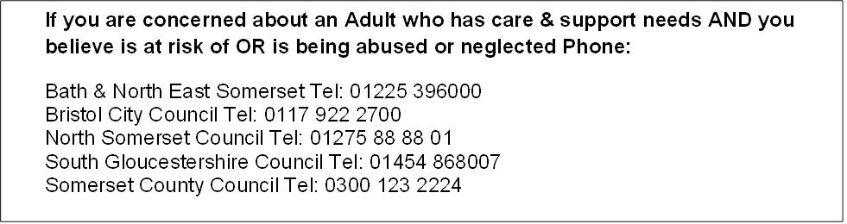

NEGLECT
Ignoring medical, emotional and physical care needs.
PSYCHOLOGICAL
Threats of harm, humiliation, blaming, controlling or intimidation.
FINANCIAL
Theft, fraud, misuse of property possessions or benefits.
SEXUAL
Rape, indecent exposure, inappropriate touching

MODERN SLAVERY
Human Trafficking, forced labour or domestic servitude

ORGANISATIONAL
Includes neglect or poor care practice.

We’d love to hear how you promoted Stop Adult Abuse Week and to gain feedback for next year. You can give your feedback through completing this short survey.

