
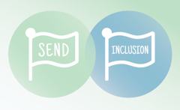
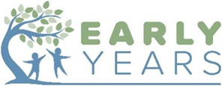

Early Years Inclusion Support Funding (EYISF) review to request banding change

This review can be submitted 3 months and 2 cycles of APDR after EYISF was originally awarded to request a change in banding. The request will be considered at the EYISF and TSF panel meeting.

Child’s Details
Child’s name |  | DOB
Setting name
Date Funding Awarded |  | Banding Level  (A, B or C)

How is the funding being used?
(Has the funding been used for staff training, to enhance the adult ratio in the setting, for resources etc)

What progress has been made towards achieving the outcomes (as stated on application)

Outcomes stated on application | Progress/impact  Include has the outcome been ‘fully, mostly, partly, not’ met
Child’s voice | Parents/Carers voice

Which professionals (or new referrals for support) have been involved during the funding period?

Professional |  | Additional advice / recommendations / additional information on child’s needs
Community Paediatrician
SALT
Educational Psychologist
Other

What are the significant changes in the needs of the child?

What Actions are you planning to take in order to meet the child’s needs in the next 6 months?

2 cycles of APDR and any professional reports received since the start of funding should be submitted as supporting documentation alongside this request for panel to review banding.

By signing this form, you are confirming you are following the Graduated approach (APDR) to support the individual child and have evidence of APDR cycles.

Practitioner name | Practitioner signature | Date
Parent/carer name | Parent/carer signature | Date

Please submit this review form to accessandresponse@southglos.gov.uk

