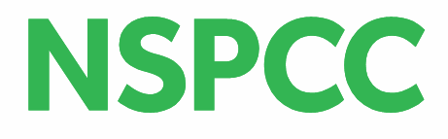

Schools Service in Bristol & South Gloucestershire – Update July 2022
The NSPCC Schools Service has a range of services, resources and support for schools, professionals, and parents/carers, to help keep children safe.
These include:
- Speak Out. Stay Safe – our safeguarding programme for Primary Schools
- PSHE and RSE resources & lesson plans – including Talk PANTS and Making Sense of Relationships
- Keeping Children Safe Online – resources for children, professionals, and safety guides for parents
- Free Online Safety Workshops for Parents & Carers
- Home or Out Alone – guide to help parents decide if their child is ready to stay home alone
- NSPCC elearning – online training courses for schools
- Safeguarding in Education – monthly update emails
- Safeguarding In Education Self-Assessment Tool
Our reach
The Schools Service has supported 90% of primary schools in Bristol, and 87% of schools in South Gloucestershire. We look forward to working with you to reach all schools and help keep even more children safe.
For more information, please contact Sharon Edwards, Sharon.Edwards@NSPCC.org.uk Tel: 01793 683112 Schools Coordinator for Bristol & South Gloucestershire
-----------------------------------------------------------------------------------------------------------------------------------------------
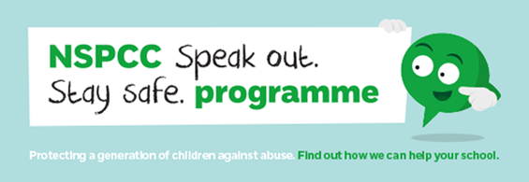
Speak Out. Stay Safe - online programme
Our safeguarding programme for 5–11 year-olds. It helps children recognise the signs of abuse, know that they’ve got the right to be safe, and lets them know where to get help if they have any worries – big or small – including our Childline service. The programme includes age appropriate, pre-recorded assemblies (introduced by Ant & Dec, no less!) for Key Stages 1&2, engaging activities and resources, with full teaching guidance. We also provide subtitled and British Sign Language versions, as well as our specially adapted SEND programme.
For more information and to sign up go to Speak out Stay safe programme | NSPCC Learning
A film for families to watch together at home is here Speak out Stay safe programme | NSPCC Learning
-----------------------------------------------------------------------------------------------------------------------------------------------
Speak Out. Stay Safe – SEND programme
Our flagship programme has been specifically adapted for pupils with a range of special educational needs and disabilities (SEND) and is aimed at those in Key Stages 2&3. The programme is delivered over 6 sessions, with full lesson plans, teaching resources, films and slideshows for teachers to use.
To request the SEND programme, register here Schools SEND form | NSPCC Learning
Information about our other SEND resources for schools - Children with special educational needs and disabilities (SEND) | NSPCC Learning
PSHE and RSE Resources
Making sense of relationships: PSHE lesson plans for KS2-4 on personal safety and healthy relationships
Making sense of relationships teaching resources | NSPCC Learning
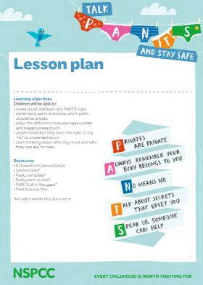
Talk PANTS
With the help of our friendly dinosaur Pantosaurus, Talk PANTS is a simple conversation to help keep children safe from sexual abuse. PANTS guides and resources, including Makaton and BSL videos.
Talk PANTS & Join Pantosaurus - The Underwear Rule | NSPCC

-----------------------------------------------------------------------------------------------------------------------------------------------
Keeping Children Safe Online
Staying safe online | Childline – Resources and advice for children such as What to do if you’re worried about something online; How to feel good on social media; setting up privacy settings etc.
Keeping children safe online | NSPCC – Online Safety Guides for Parents, and resources for professionals
Online Safety Workshops for Parents & Carers – Free, for schools and community organisations. Can be delivered face-to-face or online. Exploring the general risks for young people, how parents/carers can manage these, and a focus on specific topics such as livestreaming, sharing nudes, parental controls etc
Online safety training | NSPCC Learning - Online Safety Training for Teachers, to help keep up to date with what children and young people are doing online, and how to manage the risks. Remote, 4-hour course to be completed in own time. £30pp
-----------------------------------------------------------------------------------------------------------------------------------------------
Training & Consultancy for Schools and Professionals
NSPCC elearning: online courses | NSPCC Learning A wide range of elearning courses to support you in all aspects of child protection and safeguarding, including:
- Harmful sexual behaviour in schools
- Safeguarding children with SEND
- Online safety
----------------------------------------------------------------------------------------------------------------------------------------------
Other useful links
- Childline | Childline Our Kidzone with advice, support, message boards, as well as games, wellbeing videos, and activities like the Calm Zone, Art Box & Mood Journal
- Support for parents | NSPCC Advice & accessible guides for parents/carers on a range of topics, from having difficult conversations, and talking about racism, to working from home
