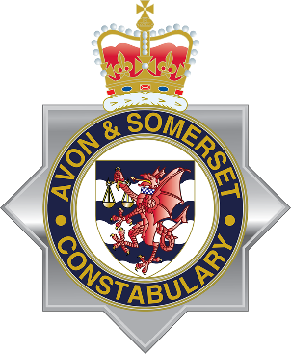
29 February 2024
A joint message from South Gloucestershire Council and Avon and Somerset Police
Dear parent/carer,
We are sure you are aware of recent shocking and tragic events in the wider Bristol area associated with knife crime and we recognise the impact these incidents are having on students and young people in South Gloucestershire as well as on families and the wider community.
We fully appreciate that you may have concerns about the safety of your child following these events, and so we are jointly writing to you to explain the work being undertaken in South Gloucestershire to tackle knife crime.
We want to reassure you that we understand and share your concerns about knife crime, and we are working together as partners and alongside our communities to tackle the root causes of this issue. South Gloucestershire Violence Reduction Partnership, which includes the council’s community safety team, children’s social care, police, schools and other partners, is committed to educating young people about the dangers and impacts of knife crime and is working hard to keep them safe.
We have produced a guide on starting conversations about knife crime for parents and carers of young people and the dangers of carrying a bladed weapon. The guide also provides links and contacts for further support put together courtesy of the Ben Kinsella Trust, a charity which works to educate young people on the dangers of knife crime and help them make positive choices to stay safe. Further information is available on the council website and at the end of this letter.
We hope you find this information helpful.
Police signatory
Cllr Claire Young Cllr Ian Boulton
Leader Co Leader
South Gloucestershire Council South Gloucestershire Council
If your child is in need of immediate support, they can use the following services:
Young Victims: The Young Victims Service (YVS) provides help and support to young people who have been victims of crime, anti-social behaviour or domestic abuse: www.youngvictims.org.uk
2 Wish: Support for those affected by sudden death in young people. England - 2 Wish
Childline: call 0800 11 11 (under 19)
Kooth: Online anonymous mental health support for young people www.kooth.com
Shout: 24/7 support if you need to talk (or text, or online chat): text the word 'SHOUT' to 85258
Samaritans: call 116 123

If your child has information they wish to pass on about a crime:
Fearless: Part of Crimestoppers, Fearless enables young people to pass on information about crime 100% anonymously: www.crimestoppers-uk.org/fearless

