Learning and Improvement Framework
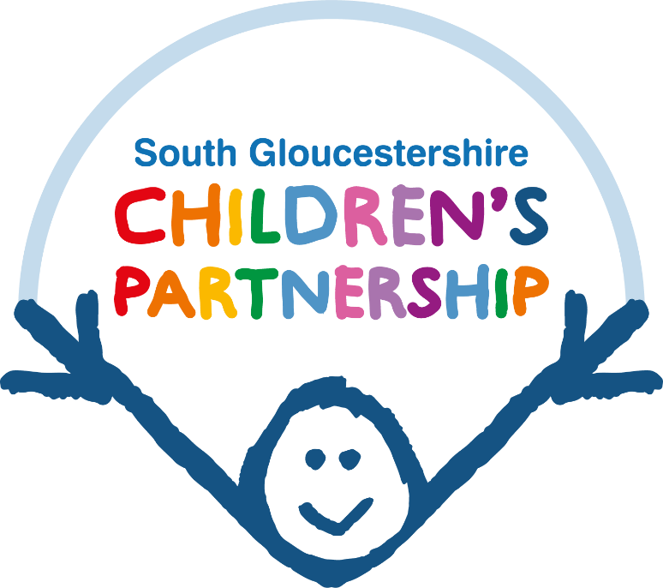

South Gloucestershire Children’s Partnership

September 2022
Date for Review; September 2024

Introduction
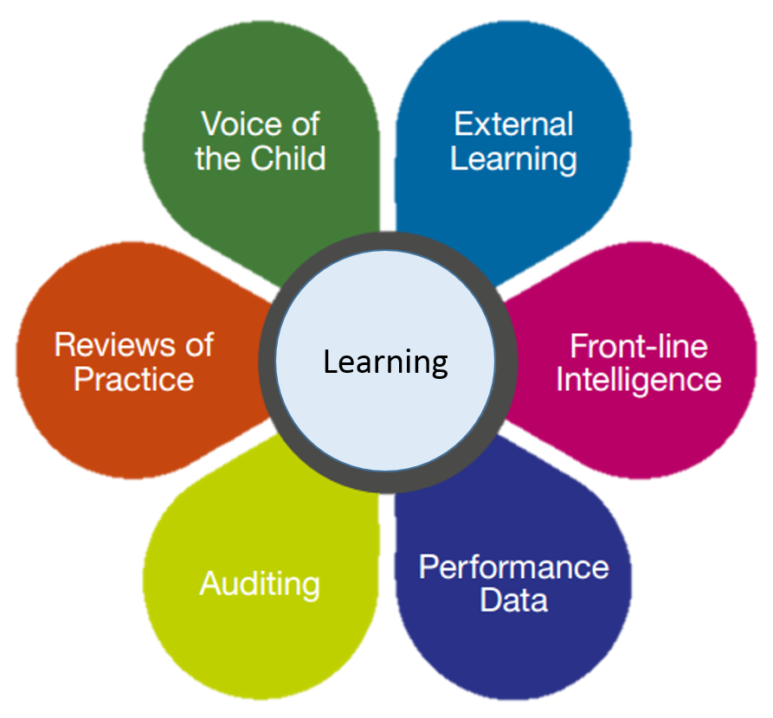
The South Gloucestershire Children’s Partnership is committed to continuous Learning and Improvement. It is important that learning is identified, disseminated, and implemented into practice so that there can be an improvement in outcomes for children and families.
Learning is identified in a number of ways, for example:
- Local and National Child Safeguarding Practice Reviews, the Rapid Review Process and other non-statutory learning reviews
- Multi-agency auditing and single agency auditing by partner organisations working with children in South Gloucestershire.
- Annual Section 11 audits
- Listening to feedback, compliments and complaints
- External inspections, peer review, independent scrutiny
- Listening to the views of children and families
- Review of Data
- Listening to the views of practitioners and managers, workforce training needs analysis

Method | Learning Process
Reviews | Working Together to Safeguard Children 2018 requires that local authorities must notify the National Child Safeguarding Practice Review Panel of incidents where they know or suspect that a child has been abused or neglected and a child has died or been seriously harmed.  Serious Incidents lead to a Rapid Review being undertaken in line with statutory guidance and within 15 working days of the notification. Following a rapid review, a recommendation about whether to undertake a Child Safeguarding Practice Review (CSPR) is made.  In South Gloucestershire the Children’s Partnership Child Safeguarding Practice Review Subgroup oversees all Rapid Reviews and CSPRs.  Learning from Local and National CSPRs, Rapid Reviews and learning reviews is shared using single page practitioner summaries, workshops and reports are published on the Partnership Website on this page.  There is an expectation that organisations share the learning to their staff and ensure it is embedded.  The learning is also shared with the commissioned trainers delivering the multi agency safeguarding training in South Gloucestershire so that this can be incorporated into training.  Action plans arising from CSPRs are monitored, followed up and implemented by the CSPR sub group until they are complete.
Training and Development | The South Gloucestershire Children’s Partnership commissions a multi-agency training programme which is agreed by the partnership. The programme is varied and incorporates face to face and virtual courses, workshops, conferences, and e-learning.  The programme is adapted through the year as needs dictate and covers issues arising from Child Safeguarding Practice reviews, as well as priorities set as part of the business plan. Trainers with subject matter expertise are commissioned to deliver the multi-agency programme. Immediate and follow up evaluation questionnaires are collected for feedback and a quarterly report provided to the Senior Officer Group.  Training Needs Analysis helps to inform the programme of training.  The Children’s Partnership also commissions training for volunteers and people working in the Night Time Economy and provides Bitesize sessions of 45 minutes on key themes.
Audits | The Quality Assurance sub group of the Children’s Partnership undertake quarterly multi-agency audits of ten children, based on a theme. Themes are chosen based on the priorities for the Partnership and learning identified in reviews. Following each audit a single page learning brief is published for practitioners to help share the learning and prompt good practice. Links to training and resources are embedded within the briefing. The audit summaries are included in monthly partnership newsletters and published on the partnership website on this page  The QA sub group also receives summaries of single agency audits undertaken by organisations working with children in South Gloucestershire.
Self Assessment | There is an annual Section 11 self-assessment undertaken by organisations working with children in South Gloucestershire. This is a joint process with the other five partnerships in the Avon & Somerset region and follows a three year cycle. Year one is a written audit submission/survey completed by all organisations, and years two and three are conducted as peer reviews.  Individual and combined region reports with recommendations and learning are agreed by the Executive for each of the five partnerships.
Review of Data | The Data Performance Report dataset consists of multi-agency indicators on how the partnership is meeting its safeguarding priorities.  The Performance Report is analysed by the Senior Officers Group (SOG) every quarter. An overview of the Performance Data report and any areas of concern and subsequent actions are reported by exception to the Children’s Partnership Executive.
Learning from Listening | Listening to the views of children and families.  This is a priority for the Children’s Partnership and the Executive are exploring ways this can be done more effectively. The Best Start in Life Workstream have undertaken Independent Scrutiny, led by Barnardo’s about the Voice of the Child.  The Best Start for Complex Needs Workstream has a member who is a Parent Representative, and she acts as the voice of families for the workstream.  The local authority participation team have a number of different groups of young people who meet regularly, and these groups have shared their views about a variety of issues and policies, they collaborated with the creation of the Domestic Abuse Toolkit and issues discussed at their conference were included in the partnership newsletter.  Organisations working with children in South Gloucestershire have their own mechanisms for gathering feedback and the Section 11 audits gathers information from this contact.  The Partnership will also receive feedback from the Lived Experience Project underway in the local authority.
Listening to the views of Practitioners
The Children’s Partnership doesn’t have a forum to directly hear the views of practitioner outside of the Child Safeguarding Practice Review process.
During 2022-23 there should be a pilot of a practitioner forum
Listening to Complaints and Compliments
The Children’s Partnership holds a record of Resolution of Professional Differences escalations.

Scrutiny and Inspection | The Children’s Partnership Executive receive regular updates following inspections and are given updates about progress against action plans.  This has previously had a focus on the local authority Ofsted inspections and going forward needs to ensure that the others Statutory Partner Inspections are also included.

summary
This framework sets out the current position for the Children’s Partnership and meets our statutory requirement. However we acknowledge that learning and development is a continuous process and that there will be changes and improvements throughout the lifespan of this document.

Sarah Taylor
Business Manager
South Gloucestershire Children’s Partnership

