Contents:
Introduction: 2
- Why we are working with South Gloucestershire secondary schools to raise awareness of child sexual exploitation among children and young people, their parents and carers.

Assembly plan & supporting materials for children and young people: 3 - 4
- How to use the assembly plan after the Easter break
- Please give us your feedback
- Supporting materials: posters and social media posts/text message/newsletter article/email

Resources for parents and carers: 5 - 7
- Social media posts planned for CSE Awareness Day 18 March 2018
- Communicating with parents and carers through your school channels
- Supporting materials: postcard and social media posts/text message/newsletter article/email.

All the campaign materials for secondary schools and professionals are available at: www.southglos.gov.uk/CSEcampaign2018

Introduction:
Since national CSE Awareness Day 2017, local schools and the Local Safeguarding Children Board member organisations have been helping us raise awareness of CSE among children and young people, their parents and carers.
The social media campaign and electronic resources we provided to schools from March 2017 was the start of an ongoing local campaign being coordinated by the LSCB and South Gloucestershire Council. The Secondary Schools Head Teachers Forum and Secondary Partnership Inclusion Network also gave their commitment to work with us to:
- Help raise awareness of Child Sexual Exploitation, the signs to spot and how to report it
- Equip children and young people with information and guidance on how to look out for themselves and their friends and how to get support (by talking to someone they trust)
- Signpost to further information and advice online
- Together, dispel the myth that CSE wouldn’t or doesn’t happen in South Gloucestershire.

To mark CSE Awareness Day on 18 March 2018, we will be sending all secondary school Head Teachers and Designated Safeguarding Leads a specially created assembly plan for local use, together with this toolkit of electronic resources. Hard copy supporting materials including posters to display in school and postcards to hand out at parents’ evenings will also be forwarded to secondary schools’ DSLs so that you can start running assemblies after the Easter break.

All the campaign materials for secondary schools and professionals are available at: www.southglos.gov.uk/CSEcampaign2018

ASSEMBLY PLAN AND SUPPORTING MATERIALS FOR CHILDREN & YOUNG PEOPLE
How to use the assembly plan after the Easter break:
The assembly plan is provided as a PowerPoint presentation. It is aimed at all year groups and it should take no longer than 20 minutes.

Before you take the assembly you will need to look through the slides and the notes to guide you. Slides 9 and 10 require you to go through your school’s procedures for who pupils can talk to and where they can get confidential support and advice (remember to add these details to slide 10).
It is intended that slides 5, 6 and 7 should be used again in smaller class/group discussions to check understanding.

There should be good visual signage in school of how to ask for help – display the campaign posters for young people and keep parents informed by letting them know that the assembly will take place, using the postcard to hand out to them at parents’ evenings and so on.

Please give us your feedback:

Use the feedback form provided.

The assembly plan, campaign materials and feedback form are all available to download at www.southglos.gov.uk/CSEcampaign2018

Supporting materials for children and young people:

Hard copy posters will be sent to you w/c 9 April. You can also go to the campaign webpage to print further copies as required.

Facebook post (can also be adapted for an email or newsletter article for children and young people – add your school’s contact details for support as you wish):
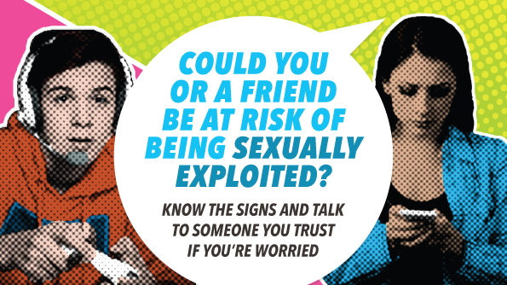
Please remember the messages from your recent assembly “Child Sexual Exploitation (CSE) - This won’t happen to me!”
If you’re worried about you or a friend, talk to someone you trust (like a teacher or a youth worker) or call the council on 01454 866000 or the Police on 101 to talk things through. If you’re in immediate danger, dial 999 straight away. Visit http://bit.ly/2mOeq99 for more information.

Tweet and text message (please adapt for your school and add your school’s contact details for support as you wish):
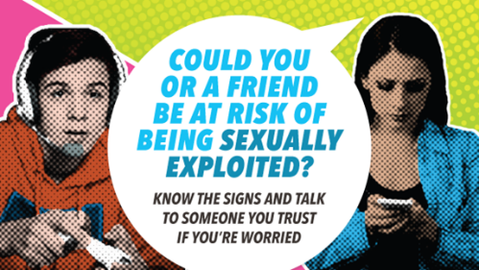
Many young people who are being sexually exploited don’t realise it. Please remember the messages from your recent assembly “Child Sexual Exploitation (CSE) - This won’t happen to me!” LOOK OUT FOR YOU AND YOUR FRIENDS http://bit.ly/2mOeq99

RESOURCES FOR PARENTS AND CARERS:

Social media posts planned for CSE Awareness Day 18 March 2018

The council and Local Safeguarding Children Board will be posting the social media messages below on Facebook and Twitter on Sunday 18 March (as follows). Please share and like them.

Facebook: 18 March CSE Awareness Day

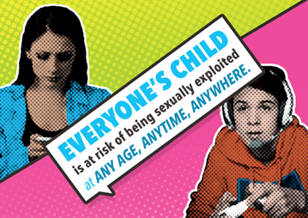
Today is Child Sexual Exploitation (CSE) Awareness Day - encouraging everyone to think, spot and speak out against abuse and highlight the issues around CSE.

We’ve been working with the Local Safeguarding Children Board and schools to raise awareness of Child Sexual Exploitation, the signs to spot and how to report it. This stage of the campaign has specifically targeted secondary school age children and young people, their parents and carers.

To mark CSE Awareness Day today, we are sending secondary schools a specially created assembly plan for local use entitled “Child Sexual Exploitation (CSE) - This won’t happen to me!”, together with electronic resources and supporting materials so that they can run assemblies after the Easter break.

Look out for messages from your child’s secondary school to tell you when the assembly will be taking place.

Advice for parents and carers: If you suspect a child may be at risk, or have any information relating to child sexual exploitation, call the council on 01454 866000 or the Police on 101. If a child is in immediate danger, dial 999 straight away.

Advice for children & young people: If you’re worried about you or a friend, talk to someone you trust (like a teacher or a youth worker) or call the council on 01454 866000 or the Police on 101 to talk things through. If you’re in immediate danger, dial 999 straight away.

Visit www.southglos.gov.uk/CSE for further information and advice.

Twitter: 18 March CSE Awareness Day

Today is Child Sexual Exploitation Awareness Day. We are working with the @SouthglosLSCB and schools to raise awareness of #CSE - signs to spot and how to report it. Look out for messages from your child’s secondary school about assemblies running after Easter.

Communicating with parents and carers through your school channels
Once you have planned when you will run your assemblies, please use the suggested text and images below and adapt them to suit your needs, to get messages out through your school channels – so that you make parents and carers aware that the assembly will be taking place and you encourage them to talk to their children and look at the web information at www.southglos.gov.uk/CSE.

Supporting materials for parents and carers:
Postcards for parents and carers will be sent to you w/c 9 April. Please decide the best way to hand the postcards direct to parents and carers e.g. at parents’ evenings, on reception.

Newsletter article/Facebook/email suggested text to use once you have planned an assembly (please amend for your school and add your school’s contact details for support if you wish):
Child Sexual Exploitation (CSE) assembly to take place (insert dates)
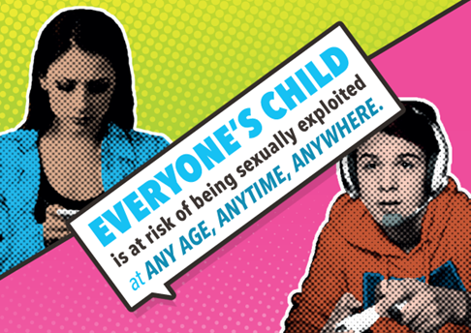
As part of a local campaign with South Gloucestershire Safeguarding Children Board, South Gloucestershire Council and Health in Schools South Gloucestershire, we are helping to raise awareness of CSE among children and young people, their parents and carers.
We will be running a specially created assembly called “Child Sexual Exploitation (CSE) – this won’t happen to me!” (add details of date(s), year groups etc).
Please look out for posters displayed around school and postcards that we will be handing out to parents and carers (add where - Reception, parents’ evenings?).
We would encourage you to talk to your child and visit www.southglos.gov.uk/CSE for further information on CSE, the signs to spot and how to report it.
(add details of your school’s support policy/contact details if parents or young people are worried).

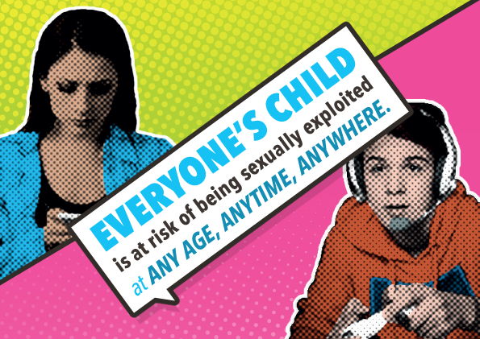
Tweet and text message (please adapt for your school):
We are working with the @SouthglosLSCB and @sgloscouncil to raise awareness of Child Sexual Exploitation #CSE - signs to spot and how to report it.
We will be running an assembly on (add date/year groups)
visit www.southglos.gov.uk/CSE for further information

All the campaign materials for secondary schools and professionals are available at: www.southglos.gov.uk/CSEcampaign2018

